H. Geometry - Bellwork #30 March 22nd, 2019

1. The bottom of a fish tank is a square with edges 14 inches long. What is the distance between opposite corners of the bottom of the fish tank? Answers have been rounded to the nearest inch.
[A] 20 in. [B] 14 in. [C] 17 in. [D] 28 in.

2. Use the Pythagorean Theorem to determine which three numbers could represent the sides of a right triangle.
[A] 64, 72, 98 [B] 65, 72, 97 [C] 65, 71, 97 [D] 64, 72, 96

3. Write in simplest radical form.
[A] [B] 14 [C] [D] 5.29

The numbers below represent the lengths of the sides of a triangle. Classify each triangle as acute, right, or obtuse.

4. 12, 13, 18

5. 20, 21, 29

Simplify each square root using simplest radical form—no decimals!

6. $\sqrt{\text{60}}$ 7. $\sqrt{\text{18}}$ 8. $\sqrt{\text{75}}$

Find the missing side of the right triangle using the Pythagorean Theorem. If your answers are not whole numbers, write them in simplest radical form.

9. $x=\text{_______}$
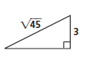

Find the missing side of each special right triangle. All answers should be in simplest radical form. Be sure to rationalize the denominator if needed. I have provided the general form of each triangle for you below.

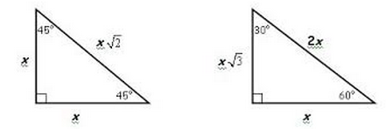

10. $\begin{aligned}x=\text{_______} \\ y=\text{_______}\end{aligned}$ 11. $\begin{aligned}x=\text{_______} \\ y=\text{_______}\end{aligned}$
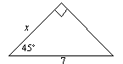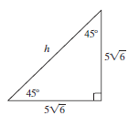

12. $\begin{aligned}x=\text{_______} \\ y=\text{_______}\end{aligned}$ 13.

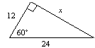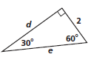

14. $\begin{aligned}x=\text{_______} \\ y=\text{_______}\end{aligned}$

