**H. Geometry - Bellwork #28 March 20th, 2019**

Find the values of x and y. Leave your answers in simplest radical form.

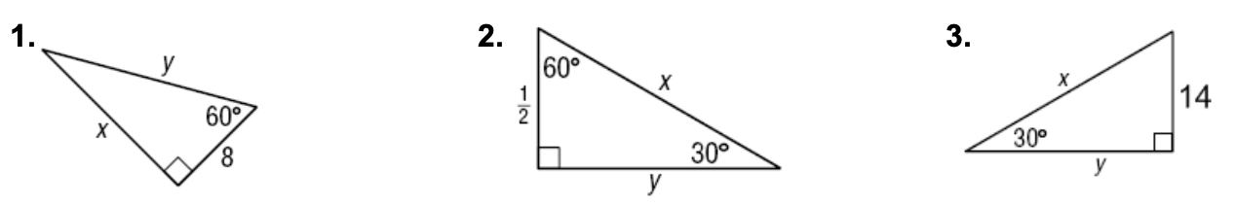

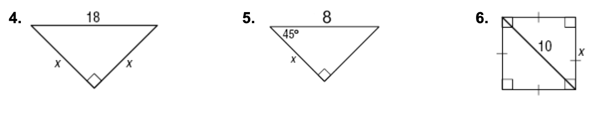

Determine whether each set of numbers will form an acute, obtuse, or right triangle.

7. , 10, 11 8. 30, 40, 50 9. 10, 11, 20

**H. Geometry - Bellwork #28 March 20th, 2019**

Find the values of x and y. Leave your answers in simplest radical form.





Determine whether each set of numbers will form an acute, obtuse, or right triangle.

7. , 10, 11 8. 30, 40, 50 9. 10, 11, 20