**H. Geometry - Bellwork #26 3/18/19**

Find the missing side in each triangle. For non-integer answers, leave them in simplest radical form.

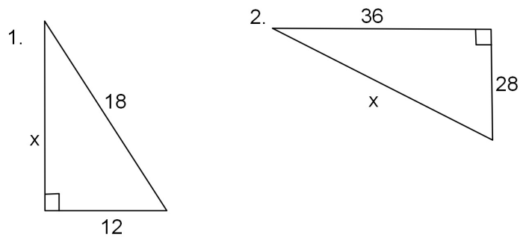

3. Does each set of lengths form a right triangle?

a. 16, 30, 34 b. 11, 59, 61

4. Is this a Pythagorean Triple?

14, 48, 50

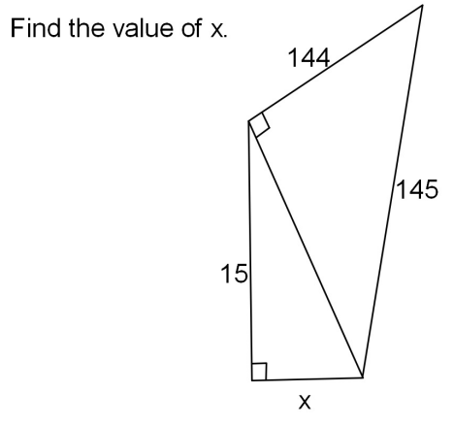

5.

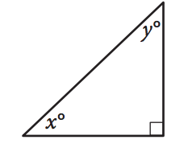6.

In the triangle above, the sine of angle x is 0.6. What is the cosine of angle y?

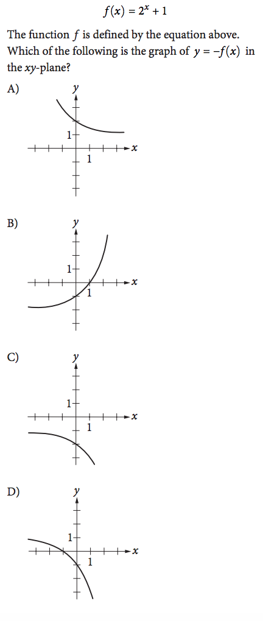

7.