**H. Geometry Bellwork #23 March 11th, 2019**

**Section 7.1 –**

1. The ratio of children to adults in one section of the theater was 16 to 24. If there were a total of 104 children in the theater how many adults were there?

2. A quality control employee samples 80 light bulbs from the production floor and finds that 3 of them are defective. If there are 1000 bulbs produced each day, how many of those will be defective?

**Section 7.2 –**

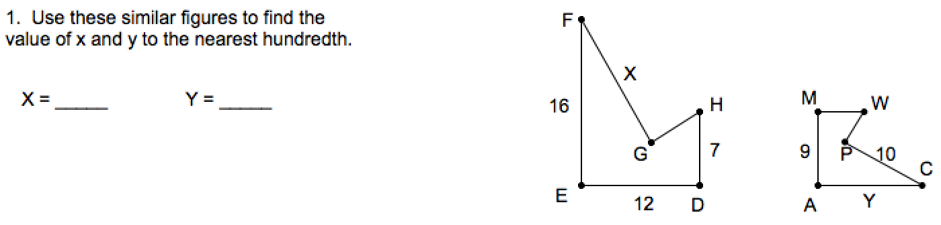

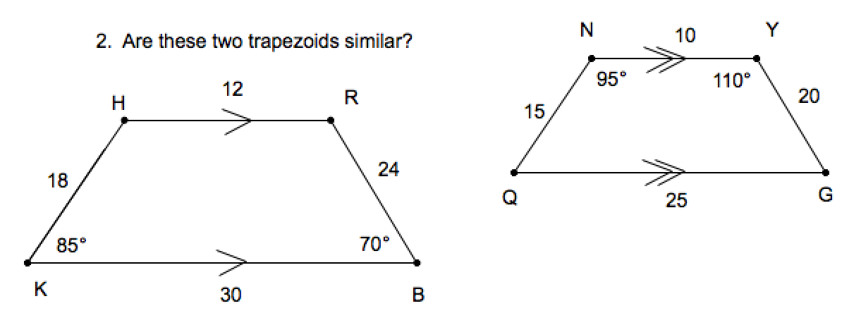

**Section 7.3 –**

