1. Find the geometric mean of the following:

a. 5 and 30 b. 10 and 30

2. If the geometric mean is $5\sqrt{6}$ and one of the numbers is 5, what is the other number?

3. Find the missing side lengths in the following triangle.

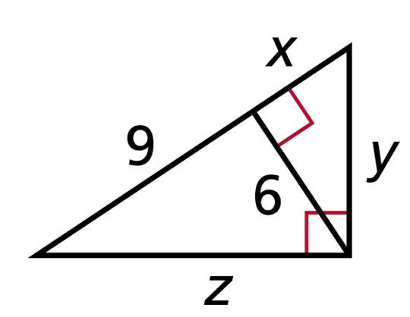

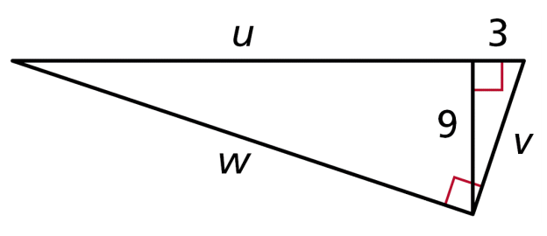4. Find the missing side lengths in the following triangle.

5. A surveyor positions himself so that his line of sight to the top of a cliff and his line of sight to the bottom form a right angle as shown. What is the height of the cliff to the nearest foot?

