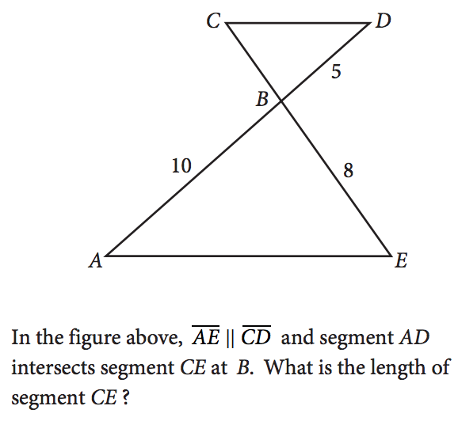1.)

2.) What is the sum of all values of $m$ that satisfy $2m^{2}-16m+8=0$

A) $-8$

B) $-4\sqrt{3}$

C) $4\sqrt{3}$

D) $8$

3.) If $\frac{{x^{a}}^{2}}{x^{b^{2}}}=x^{16}$, $x>1$, and $a+b=2$, what is the value of $a-b$?

A) 8

B) 14

C) 16

D) 18

4.) The graph of a line in the xy-plane has slope 2 and contains the point (1, 8). The graph of a second line passes through the points (1, 2) and (2, 1). If the two lines intersect at the point (a, b), what is the value of

a + b?

A) 4

B) 3

C) -1

D) -4

5.) Which of the following equations has a graph in the xy-plane for which y is always greater than or equal to

-1?

A) $y=\left|x\right|-2$

B) $y=x^{2}-2$

C) $y={\left(x-2\right)}^{2}$

D) $y=x^{3}-2$

6.) When 4 times the number x is added to 12, the result is 8. What number results when 2 times x is added to 7?

A) -1

B) 5

C) 8

D) 9