Geometry 8.1-8.2 Review Name: ______________________________

State if the three sides form a right, acute, or obtuse triangle. Show your work!

1. 10cm, 49.5 cm, 50.5 cm 2. 9 in, 12 in, 16 in 3. 5 ft, 8 ft, 9 ft

4. 5.
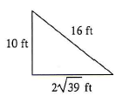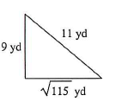

Find the missing side(s) of each triangle. Leave all answers in simplest radical form. Rationalize the denominator if needed.

6. 7.
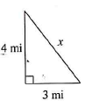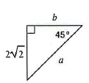

8. 9.
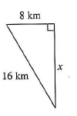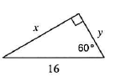

10. 11.
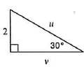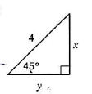

12. 13.
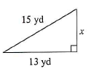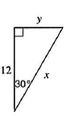

14. 15.
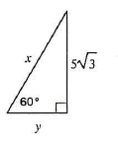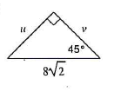

16. 17.
