Geometry 8-5: Angles of Elevation and Depression

Ob.: I can use angles of elevation and depression to solve problems.

Suppose a person on the ground look up and sees a hot-air balloon at a $\text{38}°$ angle. This is called an __________________________. The word “elevation” refers to an angle above a horizontal line.
At the same time, a person in the hot-air balloon sees the person on the ground at a $\text{38}°$angle. This is called an _________________________________. The word “depression” refers to an angle below a horizontal line.

Examine the diagram below. The angle of elevation is congruent to the angle of depression because they are _________________________________.

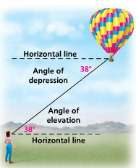

Example 1: Describe each angle as it relates to the situation shown below.
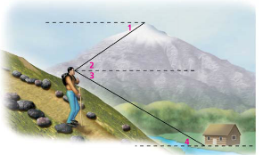

a) $∠1$

b) $∠2$

c) $∠3$

d) $∠4$
Angles of elevation and angles of depression are used in real-life situations that involve right triangles.

Example 2: To approach a runway at an airport, the pilot begins a $3°$ descent from an altitude of 2714 ft. The airport is at an elevation of 1007 ft above sea level. How many miles from the runway is the airplane at the start of this approach?

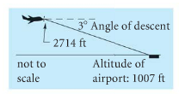

Example 3: Federal guidelines are very strict about heights of public entrances for wheelchairs. If the angle is too high, it can be difficult for people to make it up the ramp safely. Generally, wheelchair ramps have an angle of elevation of at most $8°$. If the ramp needs to get to the entrance of a building that is 4.5 ft high, how long must the wheelchair ramp be?

Example 4: Two office buildings are 51 m apart. The height of the taller building is 207 m. The angle of depression from the top of the taller building to the top of the shorter building is $\text{15}°$. Find the height of the shorter building to the nearest meter.

