Geometry 8-4: Sine and Cosine Ratios

Objective 1: I can use sine and cosine ratios to find missing sides in right triangles.
The tangent ratio, as we saw in 8-3, involves both legs of a right triangle. The sine and cosine ratios involve one leg and the hypotenuse.
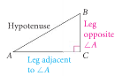sine $∠A$ =

cosine $∠A$ =

These equations can be abbreviated:

sin A = cos A =

Example 1: Writing sine and cosine ratios.
Use the triangle below to write each ratio.
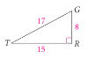

a)$\text{sin}T=$ b) $\text{cos}T=$ c) $\text{sin}G=$ d) $\text{cos}G=$

QC1: Use the triangle at the right for parts (a) and (b).

(a) Write the sine and cosine ratios for $∠X$and$∠Y$.

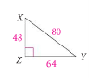
(b) When does$\text{sin}X=\text{cos}Y$? Explain.

Example 2: Use a sine or cosine ratio to find the missing side of each right triangle.
A) B)
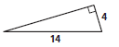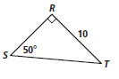

C) D)
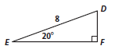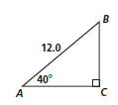

Objective 2: I can use sine and cosine ratios to find missing angles in right triangles.
If you know leg lengths for a right triangle, you can find a sine or cosine ratio for each acute angle. Conversely, if you know the sine or cosine ratio for an angle, you can use __________________
or ________________________.

Example 3: Find the given angle to the nearest degree.
A) B) C)
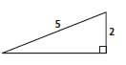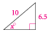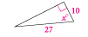

D) E) F)
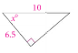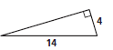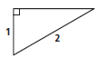

Mixed Practice:
Use a tangent, sine, or cosine ratio to find the missing side or angle in each right triangle below.
A) Find $m∠X$ B) Find x.
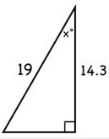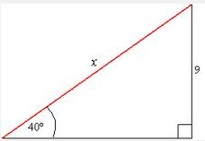

C) Find x. D)
