Geometry 8-3: The Tangent Ratio

Objective: I can use tangent ratios in right triangles to find missing sides.

Example 1: (a) Write the tangent ratios for QC 1: (a) Write the tangent ratios for
$∠T$ and $∠U\text{.}$ $∠K$and $∠J\text{.}$
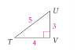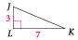

(b) How is $\text{tan}T$ related to$\text{tan}U$? (b) How is $\text{tan}K$related to$\text{tan}J$?

We can use the tangent ratio to measure distances that would be difficult to measure directly or to find missing legs in right triangles.

Example 2: Your goal in Bryce Cannon National Park is the distant cliff. About how far away is the cliff if $m∠1=\text{86}°$?
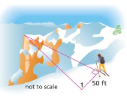

QC 2: Find the value of w to the nearest tenth.
A) B) C)
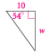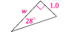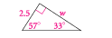

Objective 2: I can use tangent ratios in right triangles to find missing angles.
If you know the leg lengths of a right triangle, you can find the _____________ ratio for each acute angle. If you know the tangent ratio for any angle, you can use the __________________________ to find that missing angle.

Step 1: Set up the tangent ratio for an acute angle in the right triangle.

Step 2: Use the inverse tangent key on the calculator to find the angle.

Step 3: Find the other acute angle by

Example 3: Find $m∠X$to the nearest degree. Then find $m∠H\text{.}$
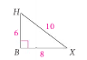

QC 3:
A) Find $m∠Y$ to the nearest degree. Then find $m∠P\text{.}$
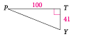

B) Find $m∠R$ to the nearest degree. Then find $m∠T\text{.}$
