Geometry 8-2: Special Right Triangles

Objective 1: I can find side lengths of a $\text{45}°−\text{45}°−\text{90}°$ triangle.

In an isosceles right triangle, both acute angles are _________. Another name for an isosceles right triangle is a _____________________________ because of the measures of the angles. The theorem we’re going to look at today shows the relationship among the 3 sides of this triangle.

Theorem 8-5: $\text{45}°−\text{45}°−\text{90}°$ Triangle Theorem

In a $\text{45}°−\text{45}°−\text{90}°$ triangle, both legs are __________________
and the length of the hypotenuse is _____ times the length of a leg. 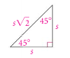

Finding the hypotenuse of a $\text{45}°−\text{45}°−\text{90}°$ triangle.
Example 1: Finding the length of each variable.
A) B)
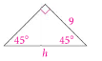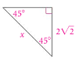

QC 1: Find the length of the hypotenuse of a $\text{45}°−\text{45}°−\text{90}°$triangle with legs of length $5\sqrt{3}$.

Finding the leg of a $\text{45}°−\text{45}°−\text{90}°$ triangle.

Example 2: Find each variable.
A)
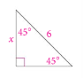

B) Find the length of a leg of a $\text{45}°−\text{45}°−\text{90}°$ triangle with a hypotenuse of length 10.

Example 3: A high school softball diamond is a square. The distance from base to base is 60 ft. To the nearest foot, how far does a catcher throw the ball from home plate to second base?
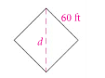

QC 3: A square garden has sides 100 ft long. You want to build a brick path along a diagonal of the square. How long will the path be? Round your answer to the nearest foot.

Objective 2: I can find side lengths of a $\text{30}°−\text{60}°−\text{90}°$ triangle

Another special type of right triangle is a $\text{30}°−\text{60}°−\text{90}°$ triangle. Today we will look at the relationship among the 3 sides of this triangle.

Theorem 8-6: $\text{30}°−\text{60}°−\text{90}°$ Triangle Theorem

In a $\text{30}°−\text{60}°−\text{90}°$ triangle, the length of the hypotenuse is twice the length of the shorter leg. The length of the longer leg is $\sqrt{3}$ times the length of the shorter leg.
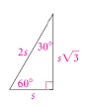

Example 4: Find the value of each variable.

A)
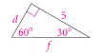

B)
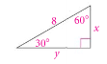

C)
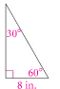

D)

