Geometry 8-1: The Pythagorean Theorem and Its Converse

Objective 1: I can use the Pythagorean theorem to find missing sides in right triangles.

Recall that the Pythagorean Theorem is a way to find missing side lengths in _______________
_____________________.

Theorem 8-1: Pythagorean Theorem
In a right triangle, the sum of the squares of the legs is equal to
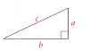

A ____________________________ is a set of __________ numbers that satisfy the equation $a^{2}+b^{2}=c^{2}$. Here are some common Pythagorean triples. Knowing them can make solving much quicker.

Example 1: Find the length of the missing side. Do the lengths form a Pythagorean triple?
A)
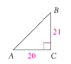

B) A right triangle has hypotenuse of length 25 and a leg of length 10. Find the length of the other leg.

Sometimes, you will be asked to simplify the square root into _____________________ form. This means NOT to get a decimal, but to remove the largest ______________________ from the radical sign and square root it. Let’s look at a couple of examples that use the simplest radical form.

Square Root Examples
$\sqrt{\text{68}}$ $\sqrt{\text{300}}$ $\sqrt{\text{375}}$ $\sqrt{\text{108}}$

Example 2: Solve for x. Leave your answer in simplest radical form.
A)

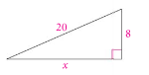

B) The hypotenuse of a right triangle has length 12. One leg has length 6. Find the length of the other leg. Leave your answer in simplest radical form.

Example 3: The Parks Department rents paddle boats at docks near each entrance to the park. To the nearest meter, how far is it to paddle from one dock to the other?
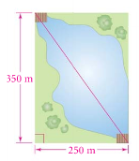

QC 3: When you want to know how far to paddle a boat, why is an approximate decimal answer more useful than an answer in simplest radical form?
Objective 2: I can use the converse of the Pythagorean Theorem to determine if a triangle is a right triangle.

Theorem 8-2: Converse if the Pythagorean Theorem
If the square of the length of one side of a triangle is equal

Example 4:
A) Is the following triangle a right triangle? Explain.

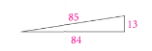

B) A triangle has side lengths 16, 48, and 50. Is the triangle a right triangle? Explain.

We can also use the squares of the lengths of the sides of a triangle to find whether the triangle is acute or obtuse.
Theorem 8-3:
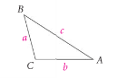
Theorem 8-4:
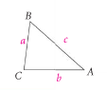

Example 5: Classify the triangle as right, acute, or obtuse, given the side lengths.
A) 6, 11 and 14. B) 7, 8 and 9. C) 10, 15, and 20

D) 5, 8, 4 E) 15, 15, 20 F) 0.5, 1.2, 1.3

