H. Geometry Review - Section 7.3-7.4 Name: ____________________________

Solve each proportion.
1. $\frac{3}{t}=\frac{4}{\text{12}}$ 2. $\frac{5}{9}=\frac{\text{75}}{x}$

Complete the following proportions. Put the correct values next to the ?.

3. If $\frac{y}{x}=\frac{3}{5}$, then $\frac{3}{y}=\frac{?}{?}$ 4. If $\frac{c}{d}=\frac{4}{7}$, then $\frac{c+d}{d}=\frac{?}{?}$

Explain why the triangles below are similar: AA~, SAS~, or SSS~. Show any work necessary to explain your reasoning below the triangles. Then write a similarity statement.
5. 6. 7.
Reason: __________ Reason: __________ Reason: __________

Statement: _________________ Statement: ________________ Statement: _________________

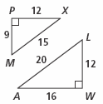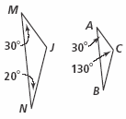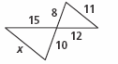

8. Draw an example of two triangles that are similar by SAS~. Include side lengths on the triangles.

The triangles below are similar. Find the value of x.

9. $x=\text{_______}$ 10. $x=\text{_______}$

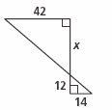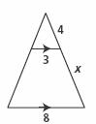

11. Mike places a mirror on the ground 40 feet from the base of a tree. He walks backwards until he can see the top of the tree in the mirror. At that point, Mike’s eyes are 5.5 feet above the ground and his feet are 8 feet from the mirror. Write and solve a proportion to find the height of the tree.

12. Shelby wants to measure the height of the flag pole in front of her school by using her height and the length of her shadow. After school, she goes outside and has a friend measure her height and shadow. Shelby’s height is 5.75 ft and the length of her shadow is 46 feet. At the same time, the flag pole has a shadow of 128 feet. Write and solve a proportion to find the height of the flag pole.

Find the values of the variables. You can leave your answers as square roots or decimals.
13. 14.
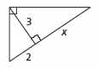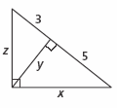

$x=\text{_______}$ $\begin{aligned}x=\text{_______} \\ y=\text{_______} \\ z=\text{_______}\end{aligned}$

