Geometry 7-5: Proportions in Triangles

Objective 1: I can use the side-splitter theorem to find missing sides of triangles

We can use similar triangles to prove the following theorem.
Theorem 7-4: Side-Splitter Theorem
If a line is parallel to one side of a triangle and intersects the other two sides,

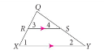

Why?? Since ____ and _____ are parallel, then ____ _____ and _____ _____, because they are _______________________ angles. So by the ____ similarity from earlier in chapter 7, the two triangles _____ and _____ are similar and have proportional corresponding sides.

Example 1: Find the value of x.
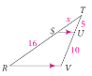

QC 1: Find the value of x in each diagram below.
A) B) C)
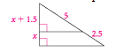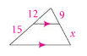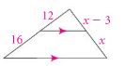

The following corollary to the side-splitter theorem says that parallel lines divide all transversals proportionally.
Corollary to Theorem 7-4
If three parallel lines intersect two transversals, then
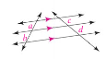

Example 2: Sail makers sometimes use a computer to create a pattern for a sail. After they cut out the panels of the sail, they sew them together to form the sail. The edges of the panels in the sail below are parallel. Find the lengths x and y.
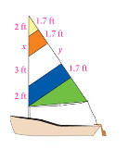

QC 2: Solve for x and y in the diagrams below.

A)
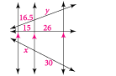

B)
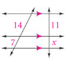

Objective 2: I can use the Triangle-Angle Bisector Theorem to find missing sides in triangles
We can use the side-splitter theorem to prove this next theorem.

Theorem 7-5: Triangle-Angle Bisector Theorem
If a ray bisects an angle of a triangle, then it divides the opposite side
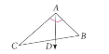

Example 3: Find the value of x.
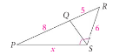

QC 3: Find the value of the variable in the diagrams below.

A) B)

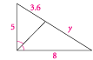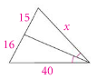

C) D)
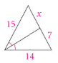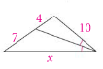

Example 4: Use the information shown in the diagram and write a proportion for the triangles below.
A) B)
