Geometry 7-4: Similarity in Right Triangles

Objective: I can find and use relationships in similar right triangles
*Triangle Activity on page 391. You will need a ruler and a sheet of computer paper.

1) Which angles have the same measure as $∠1$?

2) Which angles have the same measure as $∠2$?

3) Which angles have the same measure as $∠3$?

4) Based on your results, what is true about these three triangles?

5) Use the diagram below to complete the similarity statement.
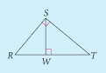

From the activity, we can conclude that when you draw an altitude in a right triangle, it creates three similar triangles.

Theorem 7-3
The altitude to the hypotenuse of a right triangle divides the triangle into two triangles that
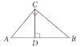

The reason all three triangles are similar is by the _______ postulate. The two new triangles have a
____________ angle and at least one angle in common with the original triangle.

In this situation, we have a length that both of the two smaller right triangles share. This length is
called the _________________________. The geometric mean in the diagram above is ______.
For any two positive numbers a and b, the _________________ of a and b is the positive number x
such that:

Example 1: Find the geometric mean of 4 and 18. *What does this mean??

QC 1: Find the geometric mean of 15 and 20.

Two important corollaries of Theorem 7-3 involve a geometric mean.
Corollary 1 to Theorem 7-3
The length of the altitude to the hypotenuse of a right triangle is

Corollary 2 to Theorem 7-3
The length of the altitude to the hypotenuse of a right triangle separates the hypotenuse
so that the length of each leg of the triangle is

Examples of Corollary 1 and 2

Example 2:
A. Solve for x. B. Solve for x and y.
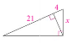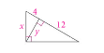

C. Solve for x and y. D. Solve for x, y and z.
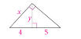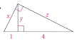

E. Solve for x, y and z. F. Solve for x, y and z.
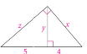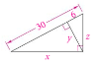

G.
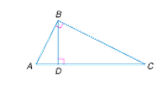

H.
