Geometry Worksheet

Similar polygons Name____________________________________

1. If polygons are similar then what do you know about the corresponding sides and the corresponding angles?

Given the similar figures, name all pairs of corresponding sides and angles. Look at the similarity statement to help.
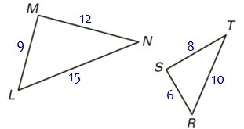
2. $Δ \text{PQR} \text{\sim } Δ \text{DEF}$ 3. $Δ \text{LMN} \text{\sim } Δ \text{RST}$ 4. $\text{ABCD} \text{\sim } \text{HGFE}$

$\overline{\text{QP}} → \text{______}$ $∠ Q ≃ \text{______}$ $\overline{\text{LM}} →\text{______}$ $∠ L ≃ \text{______}$ $\overline{\text{AB}} → \text{______}$ $∠ A ≃ \text{______}$
$\overline{\text{PR}} → \text{______}$ $∠ P ≃ \text{______}$ $\overline{\text{MN}} → \text{______}$ $∠ M ≃ \text{______}$ $\overline{\text{BC}}→ \text{______}$ $∠ B ≃ \text{______}$

$\overline{\text{RQ}} → \text{______}$ $∠ R ≃ \text{______}$ $\overline{\text{NL}} → \text{______}$ $∠ N ≃ \text{______}$ $\overline{\text{CD}} → \text{______}$ $∠ C ≃ \text{______}$
$\overline{\text{DA}} → \text{______}$ $∠ D ≃ \text{______}$

Use the similar polygons above to write the statement of proportionality for each:

$\frac{ }{}=\frac{ }{}=\frac{ }{}$ $\frac{ }{}=\frac{ }{}=\frac{ }{}$ $\frac{ }{}=\frac{ }{}=\frac{ }{}=\frac{ }{}$

Complete the similarity statement for the similar figures and then find the scale factor. REDUCE fractions!
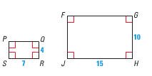
5. 6. 7.

6

$Δ \text{LKM} \text{\sim } Δ \text{_______}$ $\text{CBAD} \text{\sim } \text{_______}$ $\text{RSPQ} \text{\sim } \text{_______}$

Scale Factor: Scale Factor: Scale Factor:
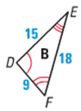
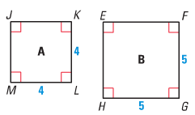
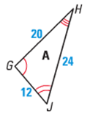
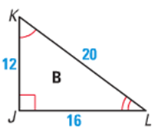
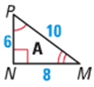
8. 9. 10.

$Δ \text{HJG} \text{\sim } Δ \text{_______}$ $Δ \text{NPM} \text{\sim } Δ \text{_______}$ $\text{KJML} \text{\sim } \text{_______}$

Scale Factor: Scale Factor: Scale Factor:

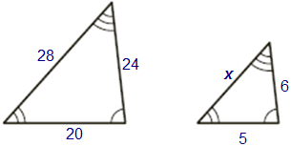
The two polygons are similar. Write a proportion and solve for x.
11. 12. 13.

Complete the similarity statement for the similar figures and then find the scale factor .
Next, write proportions and SOLVE for the missing lengths.
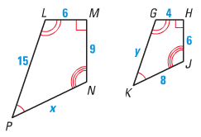
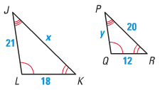
14. 15.

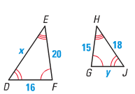
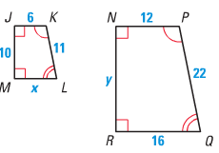

16. 17.

Are these triangles similar by the AA~ Postulate? Answer yes or no. If the triangles are similar, write a similarity statement.
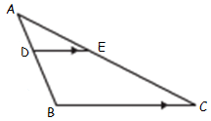
18. 19.

Similar: YES NO Similar: YES NO

$Δ \text{ADE} \text{\sim } Δ \text{_______}$ $Δ \text{EDF} \text{\sim } Δ \text{_______}$

Find the angle measurements and set up proportions to find all missing side lengths. Notice the triangles are similar by AA~.

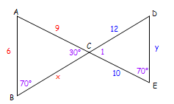
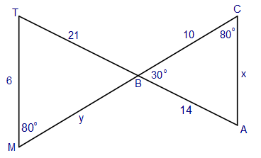
20. 21.

$m∠A=\text{_____}$ $m∠\text{TBM}=\text{_____}$ $m∠T=\text{_____}$
$m∠1=\text{_____}$$m∠A=\text{_____}$$m∠D=\text{_____}$

Proportion to find x: Proportion to find y: Proportion to find x: Proportion to find y:

Given two similar figures, find the scale factor and the ratio of the perimeters from the SMALL to the BIG.
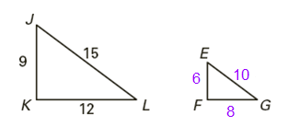
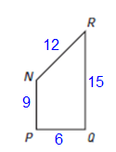
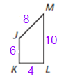
22. 23.

Scale Factor: Ratio of Perimeters: Scale Factor: Ratio of Perimeters:

