1.) Are these triangles similar? If yes, write a similarity statement.

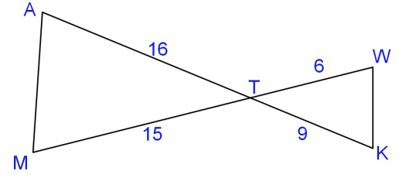

2.) Are these triangles similar? If yes, write a similarity statement.

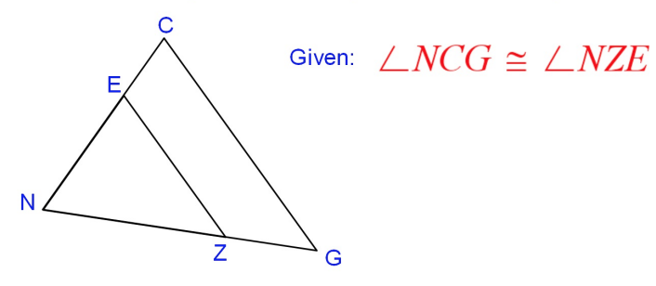

3.) Abe is 5 feet tall and is 13 feet from the mirror. The mirror is located 60 feet from the tree. How tall is the tree?

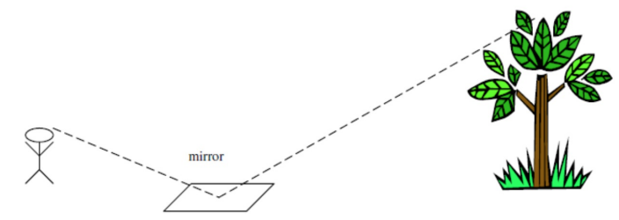

4.) Are these triangles similar? If yes, write a similarity statement. Then find the value of x.

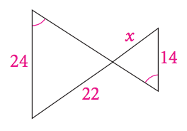

5.) Are these triangles similar? If yes, write a similarity statement. Then find the value of x.

