1.) Are the triangles similar? If yes, state what postulate or theorem was used and write the similarity statement.

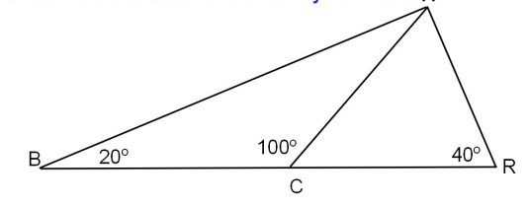

2.) Are the triangles similar? If yes, state what postulate or theorem was used and write the similarity statement.

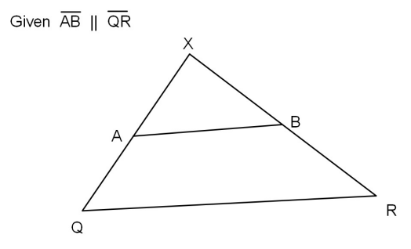

3.) Are the triangles similar? If yes, state what postulate or theorem was used and write the similarity statement.

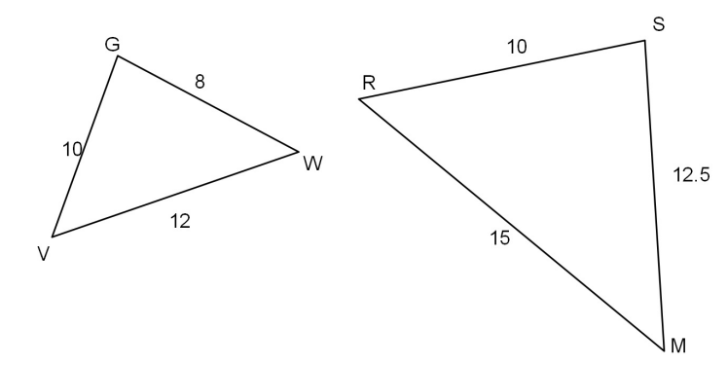

4.) Are the triangles similar? If yes, state what postulate or theorem was used and write the similarity statement.

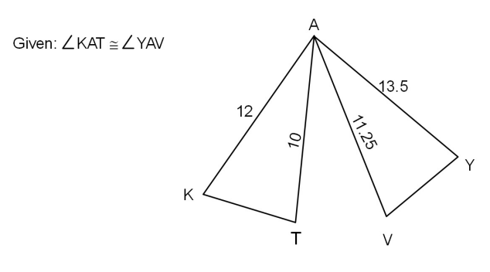  
5.) A 22-foot-tall flagpole casts an 18-foot-long shadow. How long would the shadow of a 6-foot-tall person be?

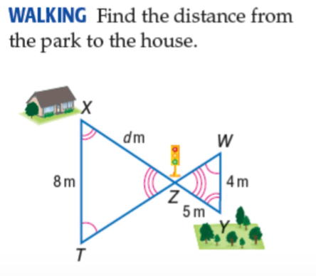

6.)

7.) In the equation ${\left(ax+3\right)}^{2}=36$, $a$ is a constant. If $x=-3$ is one solution to the equation, what is a possible value of $a$?