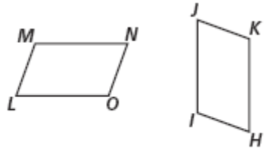

**Complete the proportions and congruence statements.**

1. 2. 3.

4. 5. 6.

**Are the polygons similar? If they are, write a similarity statement, and give the similarity ratio. If they are not, explain.**

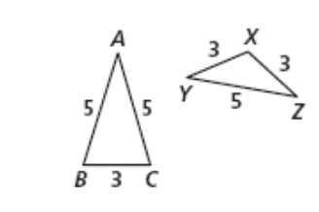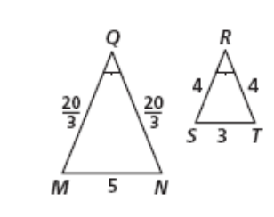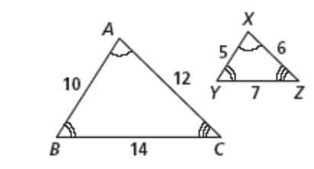

7. 8. 9.

**Bellwork #15 – February 25th, 2019 H. Geometry**

**Complete the proportions and congruence statements.**

1. 2. 3.

4. 5. 6.

**Are the polygons similar? If they are, write a similarity statement, and give the similarity ratio. If they are not, explain.**



7. 8. 9.