Geometry 7.1-7.3 Quiz Review Name: _____________________________

Questions 1 – 3 are multiple choice. Circle the correct answer for each.
1. If $\frac{a}{\text{12}}=\frac{b}{6}$, complete the following statement: $\frac{b}{a}=\frac{?}{?}$
[A] $\frac{\text{12}}{6}$ [B] $\frac{6}{\text{12}}$ [C] $\frac{a}{\text{12}}$ [D] $\frac{6}{b}$

2. If $\frac{a}{\text{12}}=\frac{b}{6}$, complete the following statement: $\frac{6}{\text{12}}=\frac{?}{?}$

[A] $\frac{a}{6}$ [B] $\frac{b}{\text{12}}$ [C] $\frac{a}{b}$ [D] $\frac{b}{a}$

3. If $\frac{x}{y}=\frac{5}{8}$, which one of the following statements will not be true.
[A] $8x=5y$ [B] $\frac{x}{8}=\frac{5}{y}$ [C] $\frac{x+y}{y}=\frac{5+8}{8}$ [D] $\frac{x}{5}=\frac{y}{8}$

Fill in the right hand side of the second proportion.
4. If $\frac{y}{x}=\frac{3}{5}$, then 5. If $\frac{a}{b}=\frac{5}{9}$, then

6. The door in a room is 8 ft. tall. An architect’s model of the same door is 2 in. high. What is the ratio of the height of the model to the real height?

Solve each proportion.
7. $\frac{4}{8}=\frac{m}{\text{22}}$ 8. $\frac{x}{7\text{.}5}=\frac{\text{12}}{2\text{.}5}$

9. $\frac{y}{y+2}=\frac{3}{4}$ 10. $\frac{x−1}{3}=\frac{\text{15}}{9}$

Use the similarity statement to complete the statements below: $Δ\text{ABC}\text{\sim }Δ\text{LMO}\text{.}$

11. $m∠C=m∠\text{___}$

12. $\frac{\text{AC}}{\text{LO}}=\frac{\text{BC}}{}$

13. Are the polygons below similar? Explain why or why not.

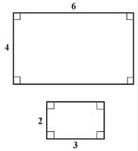

14. Are the polygons below similar? Explain why or why not.

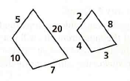

15. The scale on a map is 1 in. = 120 mi. If two cities are $6\frac{1}{2}$ in. apart on the map, what is the actual distance in miles?

Explain why the triangles below are similar: AA~, SAS~, or SSS~. Show any work necessary to explain your reasoning below the triangles. Then write a similarity statement. If they are not similar, then put “no” and leave the next two lines blank.
16. 17. .

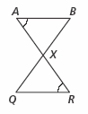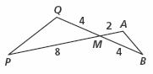

Similar? ___________ Similar? ___________
Reason: ___________ Reason: ___________
Similarity statement: _________________ Similarity statement: _________________

18. 19.

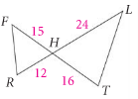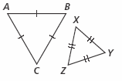

Similar? ___________ Similar? _________
Reason: ____________ Reason: __________
Similarity statement: __________________ Similarity statement: _______________

The triangles below are similar. Find the value of the variables.
20. 21.

