Geometry 7-3: Proving Similar Triangles

Objective 1: I can use AA, SAS, and SSS to prove triangles similar

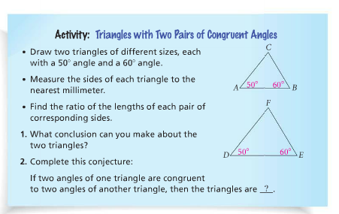
List the side lengths of the triangles below.

AB = ______ AC = ______ BC = ______

DE = ______ DF = ______ EF = ______

1) Conclusion about the triangles:

2) If two angles of one triangle are congruent to two angles of another triangle, then the triangles are ________________.

The above activity suggests the following postulate:
Postulate 7-1: Angle-Angle Similarity (AA~) Postulate

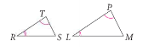

Example 1: Explain why the triangles are similar. Write a similarity statement.
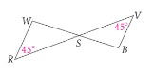

QC 1: In example 1, you have enough information to write a similarity statement. Do you have enough information to find the similarity ratio? Explain.

The next two theorems follow from the AA~ postulate.
Theorem 7-1: Side-Angle-Side Similarity Theorem (SAS~)

Example2A: Explain why the triangles below are similar.
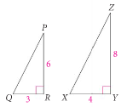

Theorem 7-2: Side-Side-Side Similarity Theorem(SSS~)

Example 2B: Explain why the triangles are similar. Write a similarity statement.

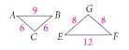
QC 2: Explain why the triangles below are similar. Which Theorem did you use?

A) B)
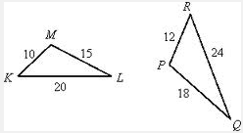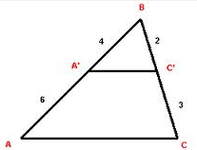

Practice Problems
Can you conclude the triangles are similar? If so, write a similarity statement and name the postulate or theorem that you used. If not, explain why.
1. 2. 3.
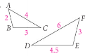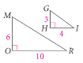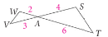

4. 5.
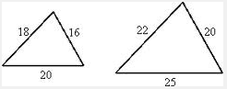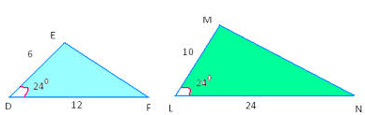

Explain why the triangles are similar. Then find the value of x.
6. 7. 8.
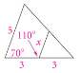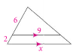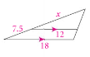

Objective 2: I can use AA, SAS, and SSS similarity in real-world applications
We can apply the AA~ postulate, SAS~ and SSS~ theorems to find missing sides in similar triangles.

Example 3: Assume the triangles are similar. Find DE.
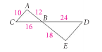

QC 3: Assume the triangles below are similar. Find the value of x.
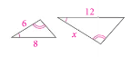

We can use similar triangles to find distances that are difficult to measure directly. This is called
____________________________. There are many methods of indirect measurement; the most common method using similar triangles formed by objects and their shadows. Another common method of indirect measurement, used in science, is using a light that reflects off of a mirror. The angle the light hits the mirror is the same angle it reflects back, forming vertical angles. (These are called ______________________________.)

Example 4: In sunlight, a cactus casts a 9-ft shadow. At the same time, a person 6 ft tall casts a 4-ft shadow. Use similar triangles to find the height of the cactus.

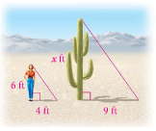

QC 4: Ramon places a mirror on the ground 40.5 ft from the base of a geyser. He walks backwards until he can see the top of the geyser in the middle of the mirror. At that point, Ramon’s eyes are 6 ft from the ground and he is 7 ft from the image in the mirror. Use similar triangles to find the height of the geyser. (Hint: Draw a picture using 2 similar triangles.)

