Geometry 7-2: Similar Polygons

Objective 1: I can determine if polygons are similar.

Two figures that have the same ________________ but not the same _____________ are __________________. The symbol for similar is . Two polygons are similar if:

(1)

(2)

The ratio of the lengths of the corresponding sides is the _______________________________. It tells us how much larger or smaller one shape is compared to the other.
To determine if two polygons are similar, be sure that the two properties above are always true.

Example 1: ABCD~EFGH. Complete each statement.
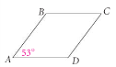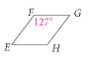
a) $m∠E=$ b) $\frac{\text{AB}}{\text{EF}}=\frac{\text{AD}}{}$ c) $m∠B=$ d) $\frac{\text{FG}}{}=\frac{\text{HG}}{\text{DC}}$

Example 2: Determine whether the triangles are similar. If they are, write a similarity statement and give the similarity ratio. If not, explain why.
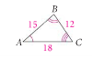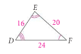

QC 2: Determine whether the polygons are similar. If they are, write a similarity statement and give the similarity ratio. If not, explain why.
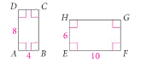

Because corresponding sides are proportional in similar figures, we can write a proportion to solve for missing side lengths in similar polygons.

Example 3: LMNO~QRST. Find the value of x.
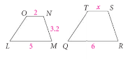

QC3: Use the figures above to find SR to the nearest tenth.

Objective 2: I can use similar polygons in real-world applications.
We can use similar polygons to find measures when using enlarged or reduced images, such as blueprints or maps.

Example 4: The scale on a map is 1 inch: 50 miles. You measure the distance between 2 cities that are on the map with a ruler and find that they are 4.5 inches apart. How far apart are the cities in miles?

QC 4: A blueprint uses a scale of 1 cm = 4 ft. If a house is 60 feet long, how long would it appear on the blueprint?

A ______________________ is a rectangle that can be divided into a square and a rectangle that is similar to the original rectangle. A pattern of repeated golden rectangles is shown below. Each golden rectangle that is formed is copied and divided again. Each new golden rectangle is similar to the original rectangle.
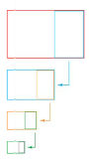
In any golden rectangle, the length and width are in the golden ratio, which is about 1.618:1.
We can write this as the following proportion:

The golden rectangle is considered pleasing to the human eye and has appeared in art and architecture since ancient times. Leonardo Da Vinci illustrated a book about the golden rectangle called The Divine Proportion. We can apply the golden ratio to real-life design problems.

Example 5: An artist plans to paint a picture. He wants the canvas to be a golden rectangle with its longer horizontal side 30 cm wide. How high should the canvas be?

QC 5: A golden rectangle has shorter sides of length 20 cm. Find the length of the longer sides.

