H. Geometry 6-1: Classifying Quadrilaterals

Objective: Classifying special quadrilaterals
Use the graphic organizer that we filled out to answer the questions below.

Example 1: Judging by appearance, QC 1: a) Judging by appearance, classify
classify DEFG in as many ways as possible. WXYZ in as many ways as possible.

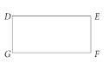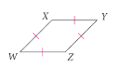

b) Which name gives the most information
about WXYZ? Explain.

Example 2: Add the labels Rectangles, Rhombuses, and Trapezoids to the Venn diagram in the appropriate places.
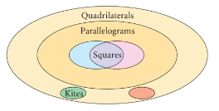

Recall from algebra that to find the slope of a line we can do:
(1) slope = $\frac{\text{rise}}{\text{run}}$
or

(2) slope =

*Parallel lines have

*Perpendicular lines (lines that meet at right angles) have

Example 2: Classifying by coordinate methods
Determine the most precise name for quadrilateral LMNP.
Step 1: Find the __________ of each side using the
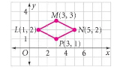

Step 2: Find the ______________ of each side using the

QC 2: Determine the most precise name for quadrilateral ABCD with vertices A (-3, 3), B (2, 4),
C (3, -1) and D (-2, -2).

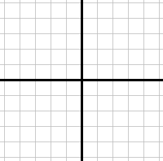

We can also use the definitions of special quadrilaterals to find the lengths of sides. If you know that sides are congruent, then ___________________________________________________.

Example 3: Find the values of the variables for the kite.
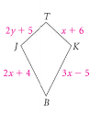

QC 3: Find the values of the variables for the rhombus. Then find the lengths of the sides.
