Geometry 5-5: Inequalities in Triangles

In this section, we will learn several theorems about the side lengths and angles of triangles and how they are “arranged”.

Theorem 5-10: If two sides of a triangle are not congruent, then

Ex 1: Using the triangle below, list the angles in order from least to greatest.

In $Δ\text{RGY},$ RG = 14, GY = 12 and RY = 20.

Theorem 5-11: If two angles of a triangle are not congruent, then

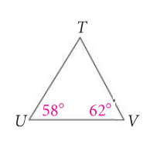
Ex 2: Which choice shows the sides of $Δ\text{TUV}$in order from shortest to longest?
[A] $\overline{\text{TV},}\overline{\text{UV},}\overline{\text{UT}}$
[B] $\overline{\text{UT}},\overline{\text{UV},}\overline{\text{TV}}$
[C] $\overline{\text{UV}},\overline{\text{UT},}\overline{\text{TV}}$
[D] $\overline{\text{TV}},\overline{\text{UT}},\overline{\text{UV}}$

Ex 3: List the sides of $Δ\text{XYZ}$in order from shortest to longest. Explain your reasoning.

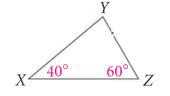

In order to be able to form a triangle, there is a special relationship among the sides. The next theorem tells us when a triangle can exist if we know the lengths of its sides.

Theorem 5-12: Triangle Inequality Theorem
The sum of the lengths of any two sides of a triangle is

Ex 4: Can a triangle have sides with the given lengths? Explain.
A. 2 cm, 7 cm, 9 cm B. 4 yd, 6 yd, 9 yd

Ex 5: A triangle has sides of lengths 3 in. and 12 in. Describe the lengths possible for the third side.

