Geometry Triangle Congruence Review #1 Name: ____________________________

Hour: ______

Decide if each pair of triangle is congruent by SSS, SAS, ASA, or AAS. Then write a congruent statement.

If the triangles are not congruent, explain why.

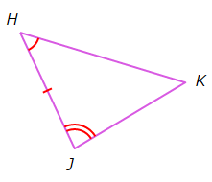1. __________________________________ 2. ___________________________________

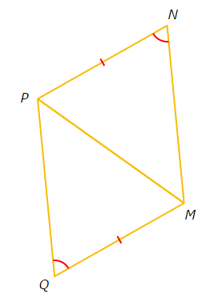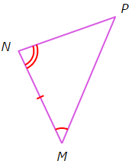

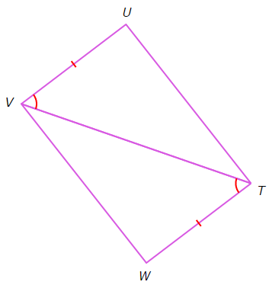3. ___________________________________ 4. ___________________________________

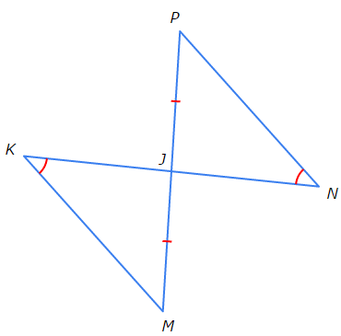

5. ___________________________________ 6. ___________________________________

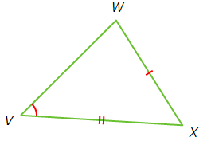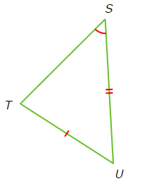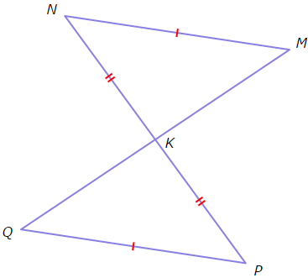

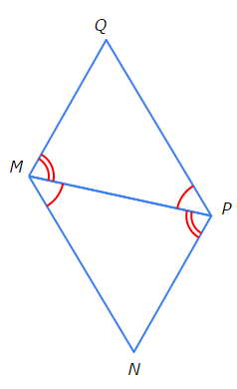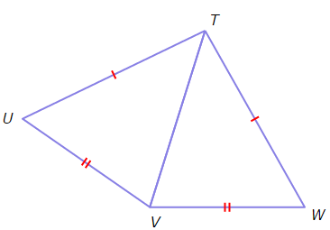7. ___________________________________ 8. ___________________________________

9. ___________________________________ 10. ___________________________________

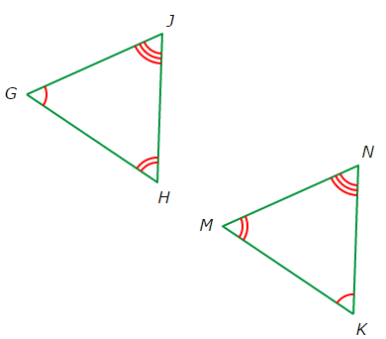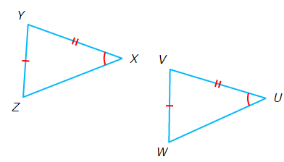

11. ___________________________________ 12. ___________________________________

