I. Name the congruent triangles.

1. 2. 

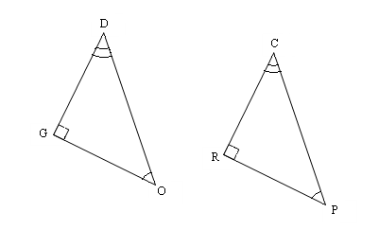

**C**

**O**

**G**

**R**

**A**

**E**

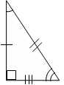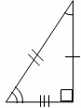3.  4. 

A

I

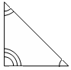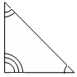

B

O

X

F

O

X

E

L

R

N

II. Name the congruent triangle and the congruent parts.

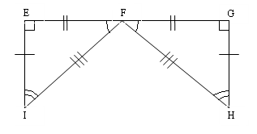5. 

 

 

 

Use the congruency statement to fill in the corresponding congruent parts.

6.    

  

7. . Find x. 8.  Find y.

R

Q

N

M

P

x°

A

B

C

D

(3y)°

21°

35o

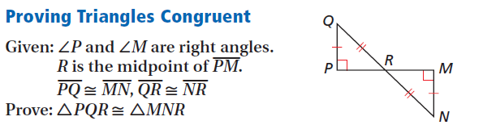

9.

**Triangle Congruence Worksheet #1**

For each pair of triangles, tell which postulates, **if any**, make the triangles congruent.

10. ΔABC ≅ ΔEFD ______________ 11. ΔABC ≅ ΔCDA ______________

C

A

D

B

C

A

B

D

F

E

12. ΔABC ≅ ΔEFD ______________ 13. ΔADC ≅ ΔBDC ______________

A

B

D

C

A

C

B

D

F

E

14. ΔMAD ≅ ΔMBC ______________ 15. ΔABE ≅ ΔCDE ______________

A

B

E

C

D

D

A

C

B

M

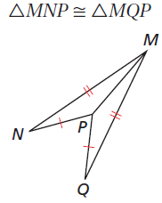

16. ΔACB ≅ ΔADB ______________ 17. ______________

A

C

D

B

**Triangle Congruence Worksheet #2**

For each pair of triangles, tell which postulates, **if any**, make the triangles congruent.

18. ΔAEB ≅ ΔDEC ______________ 19. ΔCDE ≅ ΔABF ______________

A

E

C

D

B

A

D

E

F

B

C

20. ΔDEA ≅ ΔBEC ______________ 21. ΔAGE ≅ ΔCDF ______________

A

B

C

D

E



22. ΔRTS ≅ ΔCBA ______________ 23. ΔABC ≅ ΔADC ______________

A

B

D

C

T

S

R

B

C

A

24. ΔBAP ≅ ΔBCP ______________ 25. ΔSAT ≅ ΔSAR ______________

Given: BD bisects ABC

A

T

S

R

A

D

B

P

C

For each pair of triangles, tell: (a) Are they congruent (b) Write the triangle congruency statement. (c) Give the postulate that makes them congruent.

L

O

V

E

1. 2. 3. Given: T is the midpoint of WR

E

A

A

B

D

E

C

T

R

W

a. ______________ a. ______________ a. ______________

b. Δ_____ ≅ Δ _____ b. Δ_____ ≅ Δ _____ b. Δ_____ ≅ Δ _____

c. ______________ c. ______________ c. ______________

4. 5. Given: IH Bisects WIS 6.

L

U

G

E



S

H

W

I

a. ______________ a. ______________ a. ______________

b. Δ_____ ≅ Δ _____ b. Δ_____ ≅ Δ _____ b. Δ_____ ≅ Δ _____

c. ______________ c. ______________ c. ______________

7. 8.

A

T

a. ______________ a. ______________

b. Δ_____ ≅ Δ _____ b. Δ_____ ≅ Δ _____

c. ______________ c. ______________

9. Given: I is the midpoint 10. 11.

of ME and SL

C

F



L

M

I

E

S

D

A

B

E

a. ______________ a. ______________ a. ______________

b. Δ_____ ≅ Δ _____ b. Δ_____ ≅ Δ _____ b. Δ_____ ≅ Δ _____

c. ______________ c. ______________ c. ______________

Using the given postulate, tell which parts of the pair of triangles should be shown congruent.

1. SAS 2. ASA 3. SSS

A

B

C

D

C

A

B

D

E

F

F

A

D

E

B

C

_______ ≅ ________ ________ ≅ ________ _______ ≅ _______

4. AAS 5. HL 6. ASA

P

R

S

Q

D

C

B

A

P

S

T

R

Q

_______ ≅ ________ ________ ≅ ________ _______ ≅ _______

*For each problem below, write a two-column proof on a separate piece of paper.*

I. Proving Triangles Congruent:

**1. 5.**

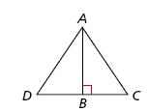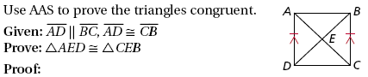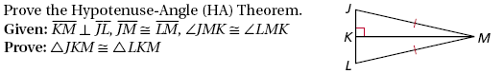

**2.**

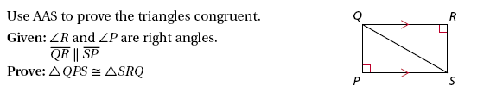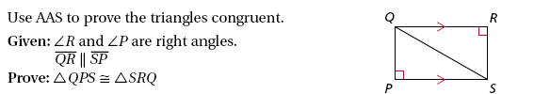

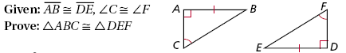**3. 6.**

**4.**

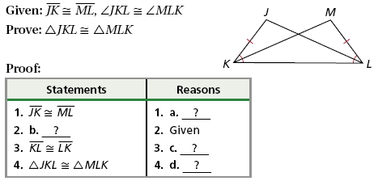

II. Using CPCTC

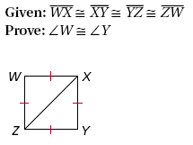**7. 10.**

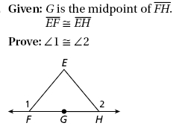

1

2

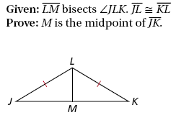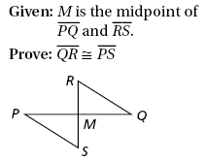**8. 11.**

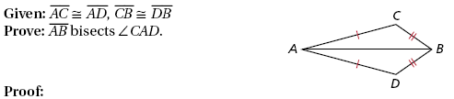

**9.**