HL Theorem Proof Notes

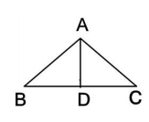1. Complete the proof below.

Given:  and 

Prove: 

|  |  |
| --- | --- |
| **Statements** | **Justifications** |
|  |  |
|  |  |
|  | All right angles are congruent |
|  |  |
|  | Reflexive Property |
|  |  |

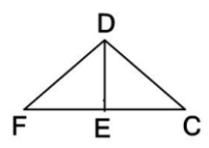

2. Complete the proof below.

Given:  is the perpendicular bisector of $\overline{FC}$;

Prove: 

|  |  |
| --- | --- |
| **Statements** | **Justifications** |
| is the perpendicular bisector of $\overline{FC}$ |  |
|  | Definition of bisector |
|  | Definition of perpendicular |
|  | All right angles are equal |
|  | Given |
|  |  |