H. Geometry – Bellwork #60 Date: __________

**State if the two triangles are congruent. If they are, state how you know.**

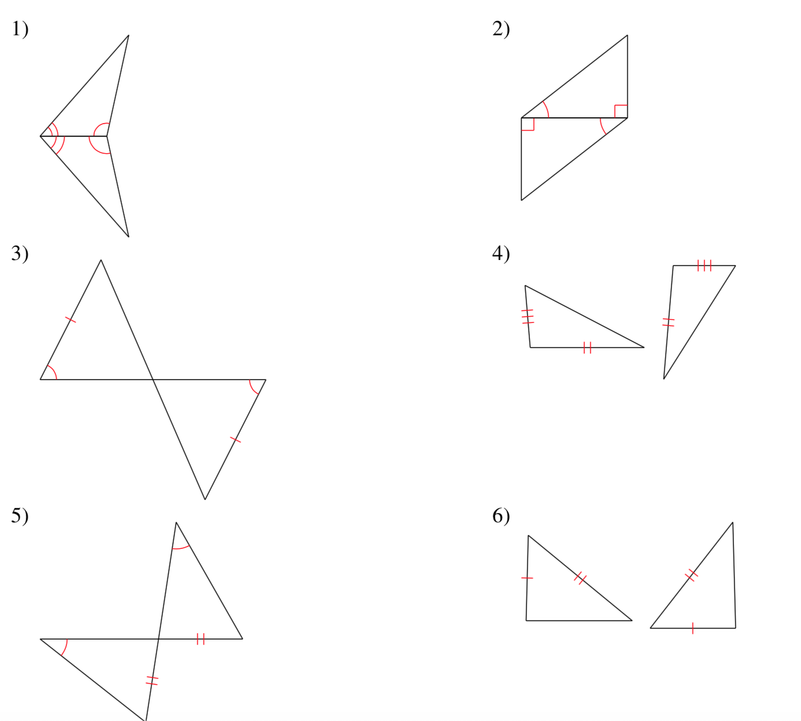

Find all the missing angle measures in the diagram shown.



1 = _____

2 = _____

3 = _____

4 = _____

5 = _____

6 = _____

7 = _____