**H. Geometry – Bellwork #60 Date: _____**

**Decide which postulate or theorem is being shown. If it is not possible to prove the triangles congruent, then write “none”.**

1. ________ 2. ________ 3. ________

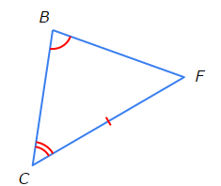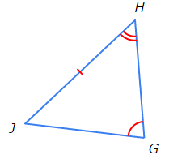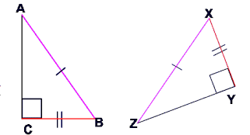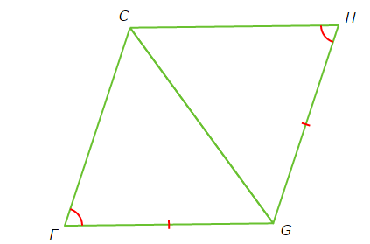

4. ________ 5. ________ 6. ________

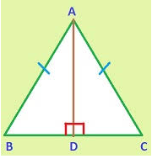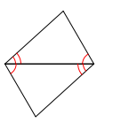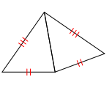

7. ________ 8. _______ 9. ________

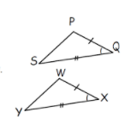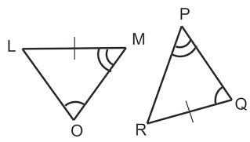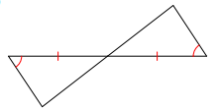

10. ________ 11. ________ 12. ________

