**H. Geometry Hypotenuse-Leg BW** Date: ______

1. Which pair(s) of triangles are congruent? Why? Write a congruence statement.

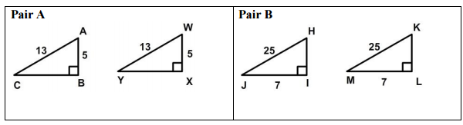

2. Are the triangles below congruent by HL theorem? If so, write a congruence statement.

a) b)

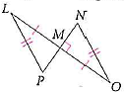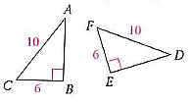

What additional information would you need to prove the triangles congruent by HL theorem?

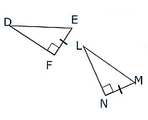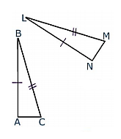3. 4.

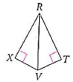5. 6.

