**H. Geometry – Bellwork #57 Date: __________**

Name the two triangles that are congruent by the ASA postulate.

1. ___________  __________ 2. ___________  __________

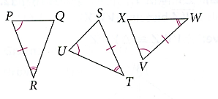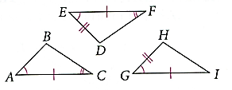

Answer each question. Drawing a triangle may be helpful.

3. Which side is included between R and S in  ________

4. Which angles include  in  ______ and _______

Write a congruence statement for each pair of triangles. Name the postulate or theorem that justifies your statement. It may help to mark the “freebies”.

5. ____________________ 6. ____________________ 7. ____________________

Justification: _________ Justification: _________ Justification: _________

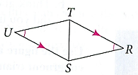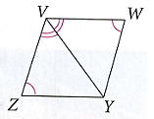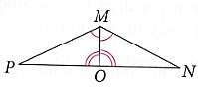

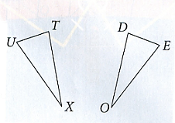8. For the triangles given, , , and . Which of the following statements is true?

A)  by ASA

B)  by AAS

C)  by ASA

D)  by AAS

9.  and . What else must you know to prove ?

a) by AAS? B) by ASA?

10. Can you prove the triangles below congruent using ASA or AAS? Explain why or why not.

