Geometry Chapter 5 Review Name: ________________________

Find the value of x.
1. x = __________ 2. x = __________

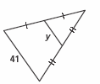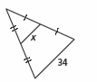

In$Δ\text{PQR}$, points S, T and U are midpoints. Complete each statement.
3. TQ = _____ 4. PQ = ______ 5. $\overline{\text{SU}}||\text{______}$
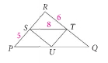

6. State two things that you can conclude from this diagram.
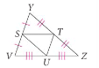

(I)

(II)

Find the value of x and KM in each figure.
7. x = ________ 8. x = _______
KM = ________ KM = _______
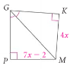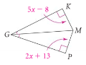

Use the figure below to answer the multiple-choice questions 9 – 11.
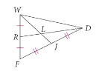
9. What is RD if RL = 54 cm?
A) 81 cm B) 108 cm C) 162 cm D) 216 cm

10. What is WL if WJ = 210 mm?
A) 70 mm B) 105 mm C) 140 mm D) 157.5 mm

11. What is JL if WL = 10 in?
A) 20 in B) 30 in C) 5 in D) 10 in

12. Decide if $\vec{\text{TB}}$ is a perpendicular bisector, angle bisector, median or an altitude.

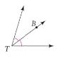

13. Decide if $\vec{\text{BD}}$ is a perpendicular bisector, angle bisector, median or an altitude.

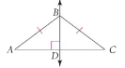

14. Decide if $\overline{\text{AB}}$ is a perpendicular bisector, angle bisector, median or an altitude.
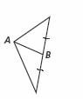

15. Decide if $\vec{\text{WT}}$ is a perpendicular bisector, angle bisector, median or an altitude.

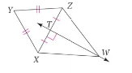

Use the triangle below to answer questions 16 – 18
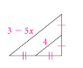

16. What is the name of the segment that is 4 units long inside the triangle?

17. How are the two labeled segments related?

18. Find x.

