Geometry 5-3: Concurrent Lines, Medians and Altitudes

Objective 1: Properties of Bisectors

When three or more lines intersect in one point, they are called _______________________.
The point at which the lines intersect is the _______________________________________. For any triangle, there are 4 different sets of lines that are concurrent. Theorems 5-6 and 5-7 tell you about two of them.

Theorem 5-6:
The perpendicular bisectors of the sides of a triangle are

Theorem 5-7:
The bisectors of the angles of a triangle are

This figure below shows $Δ\text{QRS}$ with the perpendicular bisectors of its sides concurrent at ____.
The point of concurrency of the perpendicular bisectors if a triangle is called the ____________________________________________________.
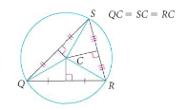

Points Q, R, and S are ___________________ from ____, the circumcenter. The circle is ___________________________ the triangle.

Example 1: Finding the center of the circle that you can circumscribe about $Δ\text{OPS}\text{.}$
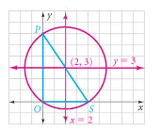

Explain why it is not necessary to find the third perpendicular bisector.

QC 1:
a. Find the center of the circle that you can circumscribe about the triangle with vertices at (0, 0), (-8, 0) and (0, 6)
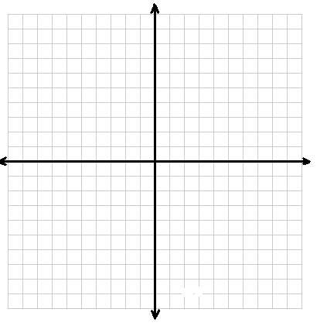

The figure below shows $Δ\text{UTV}$with the bisectors of its angles concurrent at ____. The point of concurrency of the angle bisectors of a triangle is called the _____________________________.

Points X, Y, and Z are ______________ from I, the incenter. The circle is _________________ in the triangle.
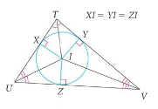

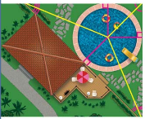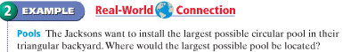

QC 2:
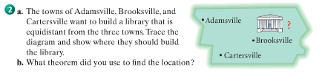

Objective 2: Medians and Altitudes

A __________________ of a triangle is a segment whose endpoints are a ______________ and
the midpoints of the ________________________.

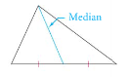

Theorem 5-8:
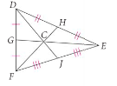
The medians of a triangle are concurrent ( )
at a point that is 2/3 of the distance from each vertex to the

*The point C is called the _____________, where all the medians meet. This point can also be called the ___________________________ because it is the point where a triangular shape would balance if you placed it on a point.

Example 3: Finding lengths of medians

In $Δ\text{ABC}$, D is the centroid and DE = 6. Find BE.
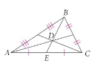

QC 3: Find BD. Check that BD + DE = BE.

An ________________ of a triangle is the ____________________ segment from a vertex to the
____________________________. Unlike angle bisectors and medians, an altitude of a triangle can be a side of a triangle or it may lie inside or outside of the triangle.

Acute Triangle Right Triangle Obtuse Triangle
Altitude is ___________ Altitude is ____________ Altitude is ____________

Example 4: Identifying medians and altitudes
a. Is $\overline{\text{ST}}$ a median, altitude or neither? Explain.
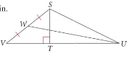
b. Is $\overline{\text{UW}}$ a median, altitude or neither? Explain.

Theorem 5-9:
The lines that contain the altitudes of a triangle are concurrent.

