Geometry 5.1-5.2 Review Name: ________________________

1. Use the triangle to identify three pairs of parallel sides.

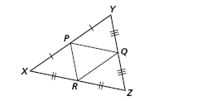

(1)

(2)

(3)

2. Find the value of x.

x = ________

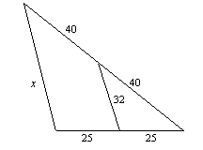

3. Find the value of x.

x = ________

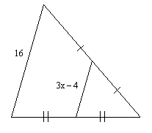
4. Points B, D, and F are midpoints of the sides of $Δ\text{ACE}\text{.}$ EC = 30 and
DF = 23. Find AC.

AC = _______

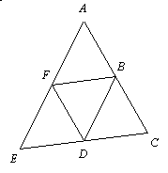

5. $\vec{\text{DF}}$ bisects $∠\text{EDG}\text{.}$ Find the value of x.

x = _______
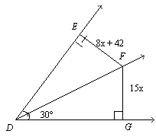

6. Q is equidistant from the sides of $∠\text{TSR}\text{.}$ Find the value of x.

x = _________
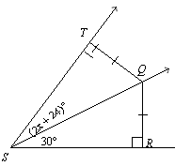
7. Which statement can you conclude is true from the diagram if $\vec{\text{AB}}$is the perpendicular bisector of $\overline{\text{IK}}$? (Circle one.)

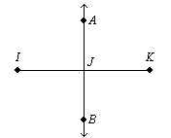
A. AJ = BJ
B. IJ = JK
C. $∠\text{IAJ}$is a right angle
D. A is the midpoint of $\overline{\text{IK}}$.

8. Q is equidistant from the sides of$∠\text{TSR}$. Find m$∠\text{RST}$. (Circle one.)

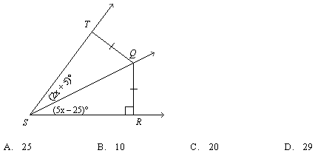
A. 25 B. 10

C. 2 D. 3

9. What is the name of the segment inside the large triangle below?
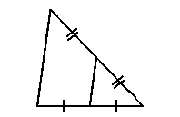

A. perpendicular bisector
B. angle bisector
C. midsegment
D. parallel line

10. What is the name of $\overline{\text{CF}}$in the figure below?
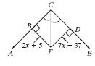

A. perpendicular bisector
B. angle bisector
C. midsegment
D. parallel line

11. What is the name of $\vec{\text{CD}}$ in the figure below?
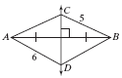

A. perpendicular bisector
B. angle bisector
C. midsegment
D. parallel line

