Geometry 5-2: Bisectors in Triangles

Objective: Properties of Perpendicular Bisectors and Angle Bisectors in a Triangle

Recall that a ________________ can divide an _________ or ___________ into 2 congruent parts.

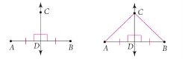

Theorem 5-2: Perpendicular Bisector Theorem
If a point is on the Perpendicular bisector of a segment, then

Theorem 5-3: Converse of the Perpendicular Bisector Theorem
If a point is equidistant from the endpoints of a segment, then

Look at the map of Washington D.C. below.
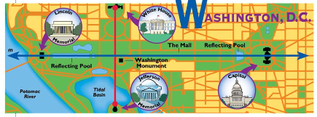

Example 1:
a. Find the set of points on the map of Washington D.C. that are equidistant from the Jefferson Memorial and the White House.

b. Describe the set of points that are equidistant from the Lincoln Memorial and the Capitol.

QC 1: Use the information given in the diagram. $\vec{\text{CD}}$ is the perpendicular bisector of $\overline{\text{AB}}$.
Find CA and DB. Explain your reasoning.
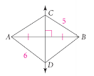

The _____________________________________ is the length of the _______________ segment from the point to the line. (You may have heard the phrase, “The shortest distance between a point is two lines.”—this is what it meant by that.)

In the diagram, $\vec{\text{AD}}$ is the bisector of $∠\text{CAB}$. If you measure the lengths of the perpendicular segments from D to the two sides of the angle, you will find that the lengths are equal. This means that D is equidistant ( ) from the two sides.
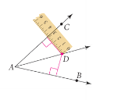

This leads us to two other theorems about bisectors.

Theorem 5-4: Angle Bisector Theorem
If a point is on the angle bisector of an angle, then

Theorem 5-5: Converse of the Angle Bisector Theorem
If a point in the interior of an angle is equidistant from the sides of the angle, then

We can combine the two theorems above into one biconditional:
“A point in the interior of an angle is equidistant from the sides of the angle

Example 2: Using the angle bisector theorem to determine the length of $\overline{\text{FD}}$?
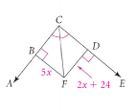

QC 2: Use the diagram below to answer parts (a) – (d).
a. According to the diagram, how far is K from $\vec{\text{EH}}$? From $\vec{\text{ED}}$?

b. What can you conclude about $\vec{\text{EK}?}$

c. Find the value of x.

d. Find $m∠\text{DEH}$.

