Geometry 5.1: Midsegments of Triangles

Objective: To use properties of Midsegments

Theorem 5-1: Triangle Midsegment Theorem
If a segment joins the ______________ of two sides of a triangle,

then the segment is _____________ to the third side of the triangle

and ___________________________________.

Example 1: In$Δ\text{EFG}$, H, J, and K are midpoints. Find HJ, JK and FG.

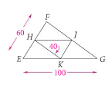

QC 1: AB = 10, CD = 18. Find EB, BC and AC.

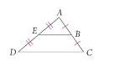

Example 2: In$Δ\text{DEF}$, A, B, and C are midpoints. Name 3 pairs of parallel segments.

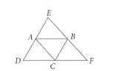

QC 2: Find $m∠\text{VUZ}$.

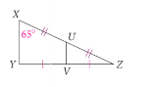

We can use the triangle midsegment theorem to find lengths of segments that might be difficult to measure directly.

Read Example 3 on page 261. After reading example 3, explain why Dean could use the triangle midsegment theorem to measure the length of the lake.

QC 3: Use the picture below to answer parts (a) and (b).

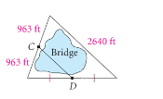
a. $\overline{\text{CD}}$ is a new bridge being built over a lake as shown. Find the length of the bridge.

b. How long is the bridge in miles?

