Geometry 4-6: Congruence in Right Triangles

Objective: The Hypotenuse-Leg Theorem

In a right triangle, the side opposite the right angle is the _______________________ and is called the _________________. The other two sides are the _________.

Right triangles provide a special case for which there is an SSA congruence rule, which we saw was not true for non-right triangle in sections 4-2 and 4-3. It occurs when _____________________ are congruent and one ______________________ are congruent.

Theorem 4-6: Hypotenuse-Leg (HL) Theorem
If the hypotenuse and a leg of one right triangle are congruent to the hypotenuse and leg of another right triangle, then

Let’s see why this theorem is true.

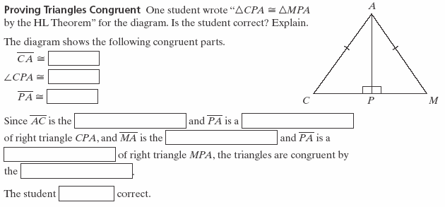

**To use the HL Theorem, you must show that three conditions are met.
1)
2)
3)
Example 1: On the tent, $∠\text{CPA}$ and $∠\text{MPA}$ are right angles and $\overline{\text{CA}}≃\overline{\text{MA}}\text{.}$ Can you use one pattern to cut fabric for both flaps of the tent? Explain.
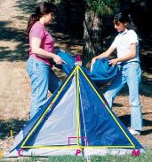

QC 1: Which two triangles are congruent by the HL Theorem? Write a congruence statement.
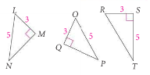

Example 2: Explain why$Δ\text{CBD}≃Δ\text{EBA}$.
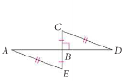

Example 3: Explain why $Δ\text{JWZ}≃Δ\text{ZKJ}$.
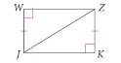

QC 3: Explain why $Δ\text{PRS}≃Δ\text{RPQ}\text{.}$
