Geometry 4-5: Isosceles and Equilateral Triangles

Objective 1: The Isosceles Triangle Theorems

Recall that an isosceles triangle has _________________________________________________

Recall that an equilateral triangle has _________________________________________________

We are going to look today at some theorems about these two types of triangles.

Theorem 4-3: Isosceles Triangle Theorem
If two sides of a triangle are congruent, then
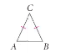

Theorem 4-4: Converse of Isosceles Triangle Theorem
If two angles of a triangle are congruent, then
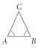

Theorem 4-5: The bisector of the vertex angle of an isosceles triangle
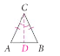

Example 1: Explain why each statement below is true using the given figure.
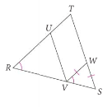
A) $∠\text{WVS}≃∠S$ B) $\overline{\text{TR}}≃\overline{\text{TS}}$

QC 1: Can you conclude that $Δ\text{RUV}$ is an isosceles triangle? Explain.

Example 2:
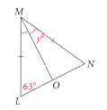
A) Find the value of y. B) Suppose$∠L=\text{43}°$. Now find the value of y.

A corollary is a statement that follows immediately from a theorem. We have 2 corollaries involving the isosceles triangle theorem.

Corollary 1: If a triangle is equilateral, then
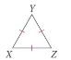

Corollary 2: If a triangle is equiangular, then
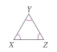

4-5 Practice Problems: Pages: 230 – 232 Problems: 1, 4, 5, 7, 8, 10-12, 20, 21, 24, 32

Use the diagram below to answer questions 1-4. Justify your answer with a theorem or postulate.
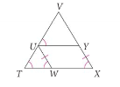

1. $\overline{\text{VT}}≃$

2. $\overline{\text{UT}}≃\text{_____}≃\overline{\text{YX}}$

3. $\overline{\text{VU}}≃$

4. $∠\text{VYU}≃$

Find the values of x and y.
5. $\begin{aligned}x=\text{______} \\ y=\text{______}\end{aligned}$ 6. $\begin{aligned}x=\text{______} \\ y=\text{______}\end{aligned}$ 7. $\begin{aligned}x=\text{______} \\ y=\text{______}\end{aligned}$
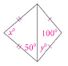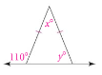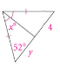

Use the triangle below for questions 8 – 11.
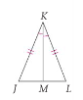

8. If $m∠L=\text{58}°$, then $m∠\text{LKJ}=\text{_______}$.

9. If $\text{JL}=5$, then $\text{ML}=\text{______}$.

10. If $m∠\text{JKM}=\text{48}°$, then $m∠J=\text{______}$.

11. If $m∠J=\text{55}°$, then $m∠\text{JKM}=\text{______}$.

