**Geometry SSS & SAS Practice CW Name: ___________________________ Hr: _____**

1. Name the congruence postulate that proves the 2 triangles below are congruent: ___________

Write the congruence statement for the triangles: ___________________________

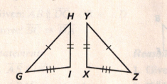

2. Name the congruence postulate that proves the 2 triangles below are congruent: ___________

Write the congruence statement for the triangles: ___________________________

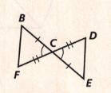

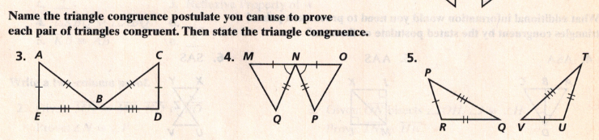

Postulate: ____________ Postulate: ____________ Postulate: ____________

 statement: ______________  statement: ______________  statement: ______________

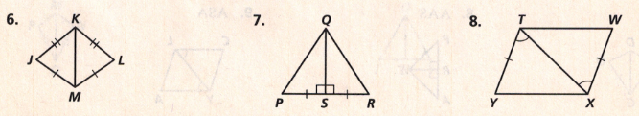

Postulate: ____________ Postulate: ____________ Postulate: ____________

 statement: ______________  statement: ______________  statement: ______________

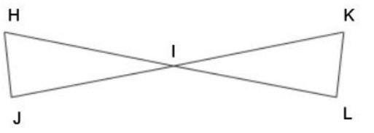9. If bisects  and what other information do you need to prove the two triangles congruent by each postulate?

a) SSS B) SAS

c) Write the congruence statement for the two triangles.

10. Complete the proof.

Given: D is the midpoint of  and 

Prove: 

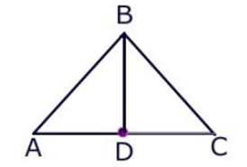

|  |  |
| --- | --- |
| **Statements** | **Justifications** |
| D is the midpoint of |  |
|  |  |
|  | Given |
|  | Definition of perpendicular lines |
|  | All right angles are congruent |
|  |  |
|  |  |

11. Complete the proof:

|  |  |
| --- | --- |
| **Statements** | **Justifications** |
|  |  |
|  |  |
|  |  |
|  |  |
|  |  |

Given: 

 bisects 

Prove: 

