**Practice 4-2: SSS & SAS Name: ____________________**

What other information, if any, do you need to prove the two triangles congruent by the given postulate?

1. By SAS 2. By SSS

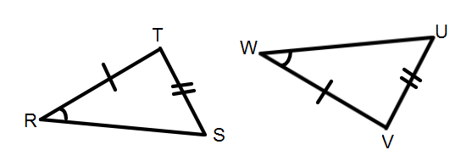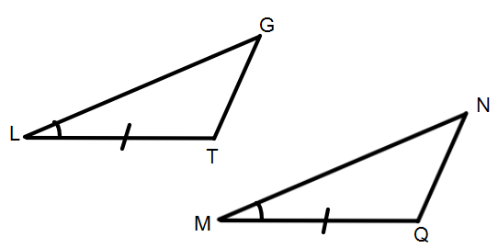

Label the triangle below as . Then answer questions 3 -6.

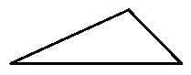

3. What sides include V?

4. What angle is included between

 and ?

5. What angles include ?

6. What side is included between W and U?

Is there enough information to prove the 2 triangles congruent in #15-20?

If so, write the postulate being used (SSS or SAS) AND the congruent statement for the triangles.

If not, write “not possible” and tell what other information you would need.

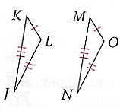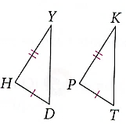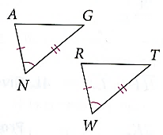7. 8. 9.

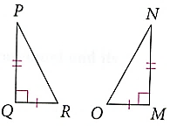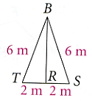10. 11. 12.

