**H. Geometry – Bellwork #52 Date: __________**

1. Complete the proof.

|  |  |
| --- | --- |
| **Statements** | **Justifications** |
|  | Given |
|  |  |
|  |  |
|  |  |

Given:  , 

Prove: 

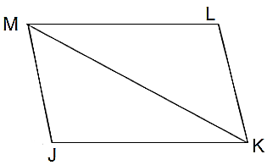

2. Complete the proof.

Given: 

|  |  |
| --- | --- |
| **Statements** | **Justifications** |
|  |  |
| K is the midpoint of |  |
|  | Definition of midpoint |
|  | Given |
|  |  |
|  |  |

K is the midpoint of  and .

Prove: 

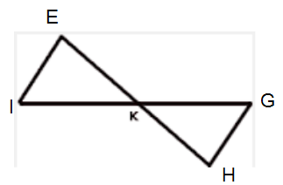

For #3-#8, are the two triangles congruent? If so, which postulate, SSS or SAS, is being used?

3. 4. 5.

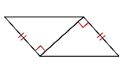 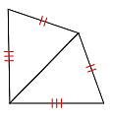 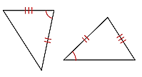

6. 7. 8.

