**H. Geometry – Bellwork #49 Date: __________**

1. Find the value of variables. 2. Find the value of the variables.

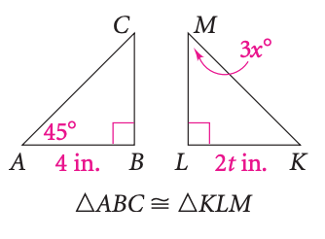 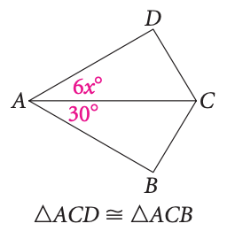





3. 4.



5. 6.

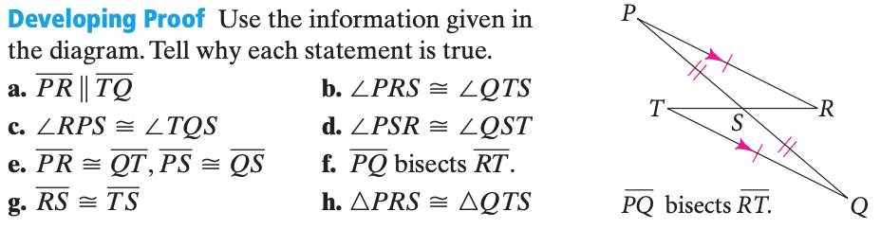

7.