**H. Geometry – Bellwork #47 Date: __________**

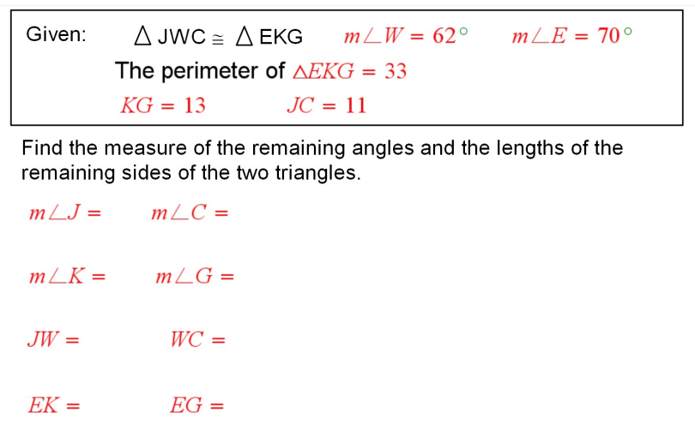

**H. Geometry – Bellwork #47 Date: __________**

