H. Geometry Bellwork #45 Date: __________

1. In $Δ\text{ABC}$, $m∠A=\text{42}°$ and $m∠C=\text{57}°$. Find $m∠B$.

$$m∠B=\text{_______}$$

2. Find all the angles measures in the diagram below.
$$\begin{aligned}m∠1=\text{_______} \\ m∠2=\text{_______} \\ m∠3=\text{_______} \\ m∠4=\text{_______} \\ m∠6=\text{_______} \\ m∠7=\text{_______} \\ m∠8=\text{_______} \\ m∠9=\text{_______}\end{aligned}$$

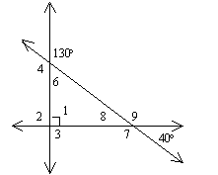

3. Find $m∠y\text{.}$

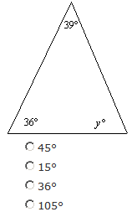

4. Classify a triangle with side lengths 23 inches, 23 inches, and 21 inches.

5. Classify a triangle with angle measures $\text{58}°,\text{104}°,$ and $\text{18}°$.

6. Decide whether a triangle could have angle measures of $\text{48}°$, $\text{22}°$, and $\text{106}°$. Explain your reasoning.

7. Find $m∠x$.

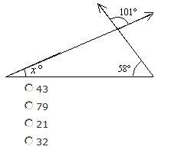

8. Identify each polygon as convex or concave.
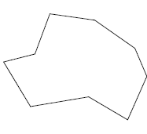
A)

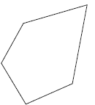

B)

9. Draw a shape that would NOT be a polygon. Explain why it is not.

10. Find the values of x, y and z.

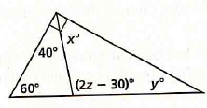

11. Name the polygon below. Then classify it by the number of sides. Then find the sum of the interior angles of the polygon.

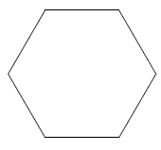

12. Name the polygon below. Then classify it by the number of sides. Then find the sum of the interior angles of the polygon.

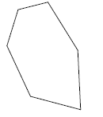

13. Find the angle measures.

