**Geometry ASA & AAS Practice CW**

**Complete the proofs.**

1. Fill in the blanks from the paragraph proof below.

a)

b)

c)

d)

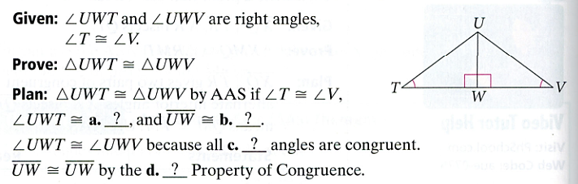

2.

Given: , 

|  |  |
| --- | --- |
| **Statements** | **Justifications** |
|  |  |
|  |  |
|  | Definition of perpendicular |
|  |  |
|  |  |
|  |  |

Prove: 

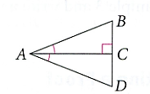

3.

|  |  |
| --- | --- |
| **Statements** | **Justifications** |
|  |  |
|  |  |
|  | Alternate Interior angles |
|  |  |
|  |  |

Given: , 

Prove: 

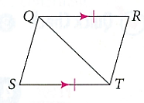

4.

|  |  |
| --- | --- |
| **Statements** | **Justifications** |
|  |  |
|  | Corresponding angles are congruent |
|  |  |
|  | Given |
|  |  |

Given: , 

Prove: 

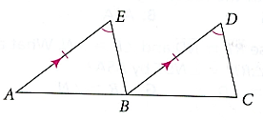

5.

Given:  bisects , 

|  |  |
| --- | --- |
| **Statements** | **Justifications** |
| bisects |  |
|  | Definition of bisector |
|  |  |
|  | Reflexive Property |
|  |  |

Prove: 

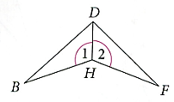

6.

Given: ,  bisects

|  |  |
| --- | --- |
| **Statements** | **Justifications** |
|  |  |
| bisects |  |
|  | Definition of angle bisector |
|  |  |
|  |  |

Prove: 

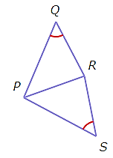

7. Draw  by each theorem or postulate. Mark congruent angles or sides correctly.

|  |  |  |  |
| --- | --- | --- | --- |
| **SSS** | **SAS** | **ASA** | **AAS** |
|  |  |  |  |