**H. Geometry Section 4.4 – Using Congruent Triangles: CPCTC**

**Objective:** I will be able to use triangle congruence and CPCTC to prove that two triangles are congruent.

With SSS, SAS, ASA, and AAS you know how to use three parts of triangles to show that the triangles are ____________________. Once you have triangles congruent, you can make conclusions about their other parts because, by definition, corresponding parts of congruent triangles are congruent. You can abbreviate this as __________.

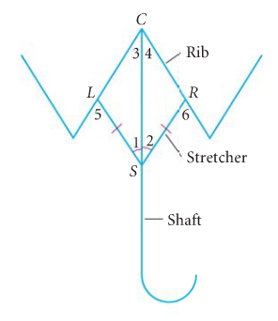Example 1: Umbrella Frames: In an umbrella frame, the stretchers are congruent, and they open to angles of equal measure.

Given: $SL≅SR$ and $∠1≅∠2$

Prove that the angles formed by the shaft and the ribs are congruent.

Prove $∠3≅∠4$

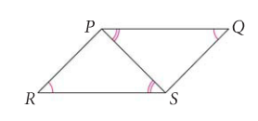QC 1: Given $∠Q≅∠R, ∠QPS≅∠RSP$

Prove $SQ≅PR$

Example 2: Given $∠DEG≅∠DEF$ are right angles; $∠EDG≅∠EDF$.

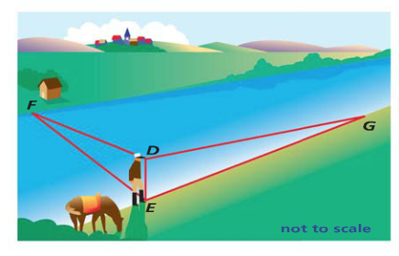

Prove $EF≅EG$