Geometry 4-3: Triangle Congruence by ASA and AAS

Objective: To prove two triangles congruent using ASA and AAS

In section 4-2, we learned that two triangles are congruent if all three sides are congruent (SSS) and if two sides and an included angle are congruent (SAS) for each triangle. We have two more ‘shortcuts’ to learn today about triangle congruency.

Postulate 4-3: Angle-Side-Angle Postulate (ASA)
If two angles and the included side of one triangle are
congruent to two angles and the included side of another
triangle, then
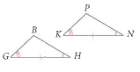

Example 1: Which triangle is congruent to $Δ\text{CAT}$ by the ASA Postulate?
(Recall: When you write a congruence statement remember to list corresponding vertices in the same order.)
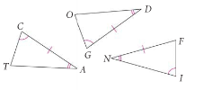

QC 1: A) Can you conclude that $Δ\text{INF}$is congruent to either of the other two triangles? Explain.

B) Can you conclude if the two triangles below are congruent by the ASA Postulate? If so, write a congruence statement. If not, explain why.
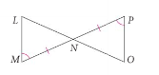

Theorem 4-2: Angle-Angle-Side Theorem (AAS)
If two angles and a non-included side of one triangle are
congruent to two angles and the corresponding
non-included side of another triangle, then
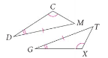

Example 2: Explain why these two triangles are congruent by AAS. Then write a congruence statement.
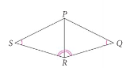

QC 2: Given that $\overline{\text{XQ}}||\overline{\text{TR}}$ and that $\overline{\text{XR}}$ bisects$\overline{\text{QT}}$, show that the two triangles below are congruent by AAS. Then write a congruence statement.
