Geometry 4-2: Triangle Congruence by SSS and SAS

Objective: To prove two triangles congruent using the SSS and SAS Postulates

In section 4-1 you learned that if two triangles have three pairs of congruent corresponding angles and three pairs of congruent corresponding sides, then the triangles are congruent.

If you know this:
$\begin{aligned}∠A≃∠X \\ ∠B≃∠Y \\ ∠C≃∠Z\end{aligned}$ $\begin{aligned}\overline{\text{AB}}≃\overline{\text{XY}} \\ \overline{\text{AC}}≃\overline{\text{XZ}} \\ \overline{\text{BC}}≃\overline{\text{YZ}}\end{aligned}$

Then you know this:
$$Δ\text{ABC}≃Δ\text{XYZ}$$

However, you do not need to know that all _____ corresponding parts are ______________ in order to conclude that two triangles are _____________. We have 4 ‘shortcuts’ that we will learn in sections 4-2 and 4-3 that will help us conclude that two triangles are congruent.

Postulate 4-1: Side-Side-Side Postulate (SSS)
If three sides of one triangle are congruent to
the three sides of another triangle, then
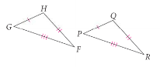

Example 1: The bridge girders are the same size, as marked. Explain why $Δ\text{ABD}≃Δ\text{CBD}\text{.}$
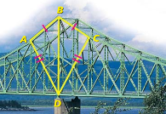

QC 1:
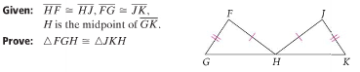

Postulate 4-2: Side-Angle-Side Postulate (SAS)
If two sides and the included angle of one triangle are
congruent to two sides and the included angle of another
triangle, then
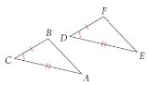

*The word _________________ is used frequently when referring to the angles and sides of a triangle. Draw $Δ\text{BNX}$below.
$\overline{\text{BX}}$ is included between ____ and ______.

$∠N$ is included between ____ and ______.

Example 2: $\overline{\text{RS}}≃\overline{\text{TK}}$. What other information do you need to prove $Δ\text{RSK}≃Δ\text{TKS}$ by SAS?
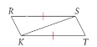

QC 2: What other information do you need to prove $Δ\text{ABC}≃Δ\text{CDA}$ by SAS?
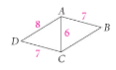

Example 3: From the information given, can you prove the two triangles congruent?
A) $Δ\text{RED}≃Δ\text{CAT}$
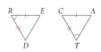

B) $Δ\text{AEB}≃Δ\text{DBC}$
