Geometry 4-1: Congruent Figures

Objective: Recognize Congruent Figures and their Corresponding Parts

Congruent figures have ________________________________________. When two figures are congruent, you can move one so that it fits exactly on the other one. Three ways to make such a move—a _________________, a _________________, and a _______________ -are shown below.

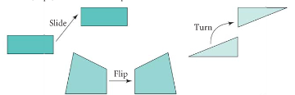

Congruent polygons have ________________________________________________________. When you name congruent polygons, always list _______________________________________.
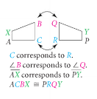

Example 1: $Δ\text{TJD}≃Δ\text{RCF}\text{.}$ List the congruent corresponding parts.
Angles: Sides:
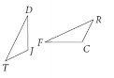

QC 1: $Δ\text{WYS}≃Δ\text{MKV}\text{.}$ List the congruent corresponding parts.
Angles: Sides:

Example 2: The fins of the Space Shuttle suggest congruent pentagons. Find $m∠B\text{.}$
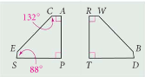

QC 2: It is given that $Δ\text{WYS}≃Δ\text{MKV}\text{.}$ If $m∠Y=\text{35}°$, what is $m∠K?$ Explain.

Two triangles are congruent when they have ___________________________________________ and __________________________________________________________.

Example 3: Decide whether the triangles are congruent. Justify your answer and write the congruence statement.

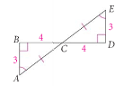

QC 3: Can you conclude $Δ\text{JKL}≃Δ\text{MNL}?$ Justify your answer.
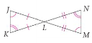

The next theorem follows from the Triangle-Angle-Sum Theorem.
Theorem 4-1
If two angles of one triangle are congruent to two
angles of another triangle, then
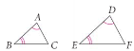

Example 4: Explain how you know that $Δ\text{ABC}≃Δ\text{LMN}$.
