H. Geometry 3.5 - The Polygon Angle-Sum Theorem Date: ____________

Objective 1: Classifying Polygons

A ______________ is a _____________ plane figure with at least ____ sides that are segments. The sides intersect only at their ____________, and no adjacent sides are _________________.

Examples of polygons Examples of non-polygons

To ________________________________________, start at any ___________ and list the vertices in order in a ___________________ or _______________________________ direction.

Ex 1: Naming Polygons
A. Name the polygon. Then identify its sides, vertices and angles.
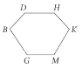
Name: Vertices:

Sides: Angles:

B. Three polygons are pictured below. Name each polygon, its sides and its angles.

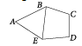

You can classify a polygon by the _________________________ it has. Let’s make a table below that shows the names of some of the common polygons.

# of Sides | Name
3
4
5
6
8
9
10
12
n

Polygons can also be classified as
______________ or _______________.

A ___________ polygon has no diagonal with points outside the polygon.

A ___________ polygon has at least one diagonal with points outside the polygon.

*IN THIS BOOK, A POLYGON IS
_____________ UNLESS OTHERWISE STATED!!!*

Example 2: Real-World Connection
The tile work in the photo below is a combination of different polygons that form a pleasing pattern. Classify the polygon outlined in red by using the table above. Then classify the polygon as convex or concave.


QC2: Classify each polygon by its sides. Identify each as convex or concave.
A. B. C.
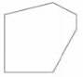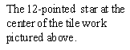

Objective 2: Polygon Angle Sums
Activity: The Sum of Polygon Angle Measures
You can use triangles and the triangle sum theorem to find the sum of the measures of the angles of a polygon. Record your data in the table below.

Polygon | # of Sides | Number of triangles formed | Sum of the interior angle measures
 | 4
 | 5
 | 6
 | 7
 | 8

Theorem 3-14: Polygon Angle-Sum Theorem
The sum of the measures of the angles of an n-gon is

Example 3: Finding a polygon angle sum
A. Find the sum of the measures of a 15-gon. B. Find the sum of the measures of a 13-gon.

C. The sum of the measures of a given polygon is$\text{720}°$. How many sides does the polygon have?

Example 4: Using the polygon angle-sum theorem.
A. Find $m∠Y$ in pentagon MRTVY below. B. Hexagon ABCDEF has all
congruent angles. Find the measure of each angle.
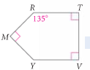
You can draw an ____________________ at any vertex of a polygon. The figures below show that the sum of the measures of the exterior angles, one at each _______________, is ___________.

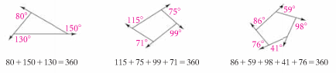

Theorem 3-15: Polygon Exterior Angle-Sum Theorem
The sum of the measures of the exterior angles of a polygon,

For the pentagon at the right:
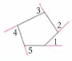

An _____________________________________ has all sides ______________________.
An _____________________________________ has all angles _____________________.
A __________________________ is both ________________ and ____________________.

Example 5: The game board below has the shape of a regular hexagon. It is packaged in a rectangular box outlined next to it. The box uses four right triangles made of foam in its four corners. Find $m∠1$ in each foam triangle.
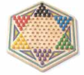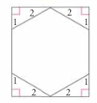

QC 5:
A. Find $m∠1$ above by using the Polygon Exterior Angle Sum Theorem.

B. Find $m∠2$. Is $∠2$ an exterior angle? Explain.

